拉脱维亚
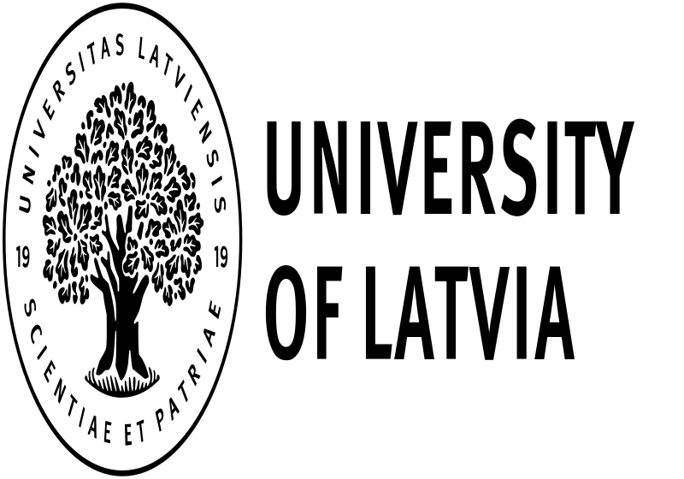
- 拉脱维亚大学 University of Latvia (https://www.lu.lv/en/)

Introduction
The University of Latvia (UL) was founded on September 28, 1919, but its origins can be traced even earlier - in the second half of the 19th century, when Latvian public and cultural workers called on Latvians to strive for knowledge and quality education.
The University of Latvia has consistently been the national, leading and most influential higher education institution in Latvia. In terms of the total number of students, the University of Latvia is also the largest university in the country. It is the largest high-profile university in Latvia, which has an important place not only in the development of the entire education system, but also in the overall growth of the country's economy.
UL is a modern center of academic and professional studies, which together with research in natural sciences, humanities, social sciences, technical sciences and medicine provides various types and levels of higher education opportunities for the residents of Latvia and other countries. LU plays a crucial role in the development of society's academic traditions, national economy, education, environment and health protection, Latvian language and culture. The opinion of the University of Latvia is important for decision-making in public administration. There are four colleges in UL with 13 faculties, including natural sciences, humanities and arts, medicine and health science, and social sciences.

交换生项目申请
- 选拔对象：本科二年级学生
- 学习期限：一学期（8月至次年1月）
- 派出名额：两名
- 我校收取费用：暨南大学第三学年学费
- 绩点及综合测评要求：均排在本专业前30%

Exchange Students
The University of Latvia is a partner university of JNU, so nominated students are welcomed by UL. For information on exchange students, please check the two websites below:
- Academic information:
https://www.lu.lv/en/gribustudet/arzemju-studentiem-eng/exchange/academic/
- Courses for exchange students:
https://www.lu.lv/en/gribustudet/arzemju-studentiem-eng/exchange/courses/

About the City
Riga is the capital city of Latvia. In its 800 years of turbulent history, everyone from German knights to Swedish kings and Soviet commissars have left their footprints, and today Latvia’s capital is an exciting European metropolis at the crossroads of eastern and northern Europe.
Riga’s astonishing skyline tells the story, as the timeless Gothic spires in the Old Town mingle with the fantastic facades of one of the world’s richest collections of Art Nouveau on the grand boulevards.
Riga is a UNESCO World Heritage site of cobblestones and breathtaking river views, as well as Europe’s Wifi capital with almost 1,000 spots to get online for free.
