韩国
- 国立釜山大学 Pusan National University
(http://www.pusan.ac.kr/eng/Main.do)
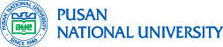
Introduction
PNU is Korea’s first national university, having been established on May 15, 1946. While leading a path to industrialization and democratization, the university has fulfilled its mission as a regional hub university, actively engaged in the great journey of Korea’s modern history. Although the University started initially with just two faculties, the Faculty of Humanities and the Faculty of Fisheries, since then, it has grown into a major research level institution covering all the major disciplines within academia. Today, the University enjoys its reputation as one of top universities in Korea.
The University now compriseds fifteen colleges, one independent division, one general graduate school, fourprofessional graduate schools and five special graduate schools, and contributes to the development of the nation by producing prominent experts and talented leaders. As of March 2018 graduates of PNU totaled 168,355 bachelor’s degree holders, 48,671 master’s degree holders, and 8,058 doctoral scholars, many of whom are playing central roles as community, national and world leaders.
With six of PNU’s academic fields placed in the Top 101-200 in the 2017 QS World College Ranking, PNU is marching to becoming a global university. Furthermore, PNU has entered agreements with over 430 universities and institutes in 50 countries around the world. In addition, here at PNU, many of our students are gaining international experiences to grow as a global leader by interacting with more than 60 foreign professors, taking one of the more than 1,000 foreign language classes offered every year, and participating in overseas dispatch and volunteer programs to cultivate expertise on global affairs and global cultures.

交换生项目申请
- 选拔对象：本科二年级学生
- 学习期限：一学期（8月至次年1月）
- 派出名额：两名
- 我校收取费用：暨南大学第三学年学费
- 绩点及综合测评要求：均排在本专业前30%

Incoming Exchange Students
Pusan National University has established cooperative academic relationships with many renowned universities all over the world to give students opportunities to study abroad at any of our partner universities through our exchange student program.
Incoming exchange students who are nominated by our partner universities are eligible for the following benefits:
- Tuition and registration fee waiver
- Free Korean language courses
- Participation in the PNU Summer School program for minimum cost
- Buddy Program: one-on-one assistance from a fellow PNU student
Exchange benefits vary from partner to partner and in some cases can be more extensive. You can check with either the international affairs office at your home university or with PNU International. You may visit this website for more information:
https://his.pusan.ac.kr/international_eng/41561/subview.do

About the City
Busan Metropolitan City, where Pusan National University is located, is a bustling city of approximately 3.5 million residents.
It is the second-largest city in Korea. Located on the southeastern tip of the Korean peninsula, Busan is one of the world’s top super ports. Its natural environment is a perfect example of harmony between mountains, rivers and sea, and features a coastline of superb beaches, such as Haeundae and Gwangan, majestic mountains, and Asia’s most sought-after hot springs. Natural endowments and a rich history have resulted in Busan’s increasing reputation as a world-class city for tourism and culture. It has become a leader in the global film industry by hosting the annual Busan International Film Festival (BIFF). Busan is considered ‘dynamic’ due to its special characteristics: the beauty of nature mixed with traditional and modern elegance, personified by open-mindedness and progressiveness of its citizens.
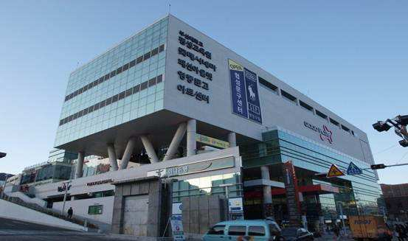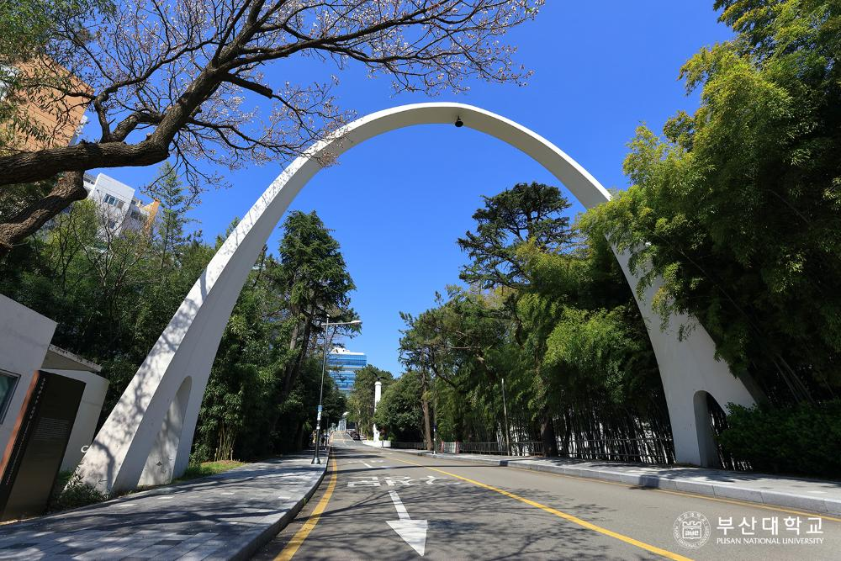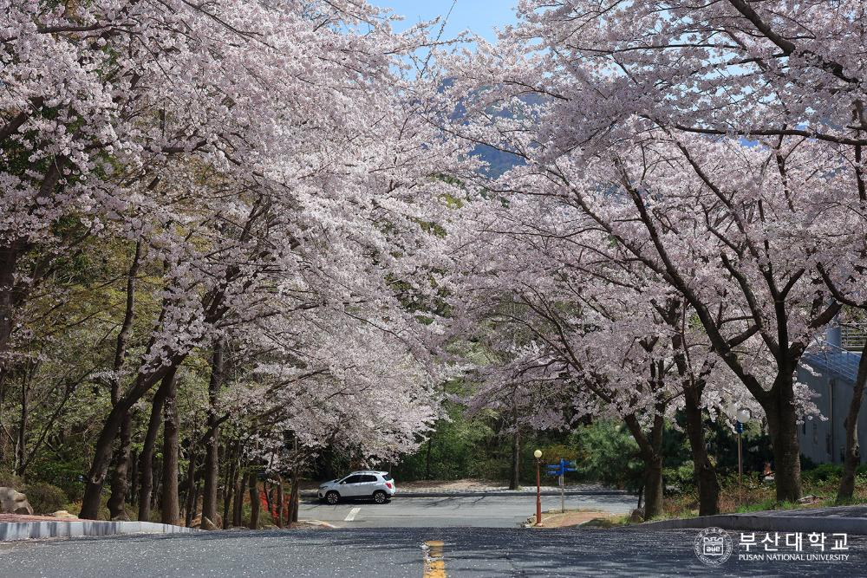
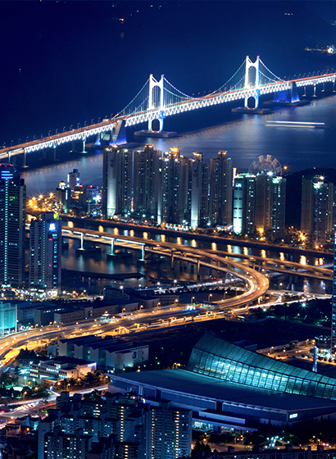

- 中央大学 Chung-Ang University
(https://neweng.cau.ac.kr/index.do)
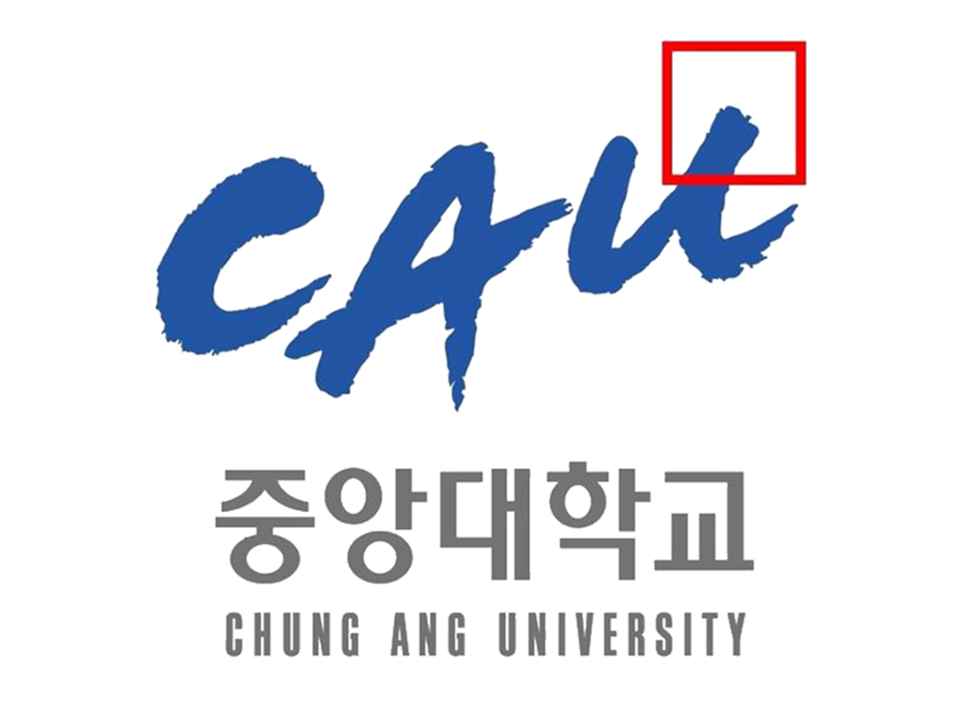

Introduction
Chung-Ang University is a private institution with 30,000 students and 982 faculty members. It consists of 10 undergraduate colleges and 16 graduate schools. It operates two campuses, in Seoul and Anseong, Korea.
Established in 1918, CAU has endured through the painful course of Korea’s modern history, upholding its ideal of "Justice and Truth". Since then, CAU has taken a leading role in nurturing intellectuals of the nation. Respected as leading institution providing quality education, CAU has sped up the pace of innovation in local education.
Fully accreditied by the Ministry of Education of Korea, CAU offers a wide range of bachelor’s, master’s and doctoral programs including a law school, global MBA programs and a medical school. Thanks to these schools’ vibrant activities, CAU gained top recognition in the nation from the MEST for the last eight years.
Furthermore, CAU is recognized as the nation’s best in the fields of pharmacy, culture and art education. With the help of its schools of art and culture, the university stands at the center of the Korean culture wave, currently sweeping Asia and beyond.
As a major private institution, Chung-Ang University is fully committed to guiding its Korean and international students to envision their life goals and achieve their maximum potential in the increasingly competitive global society.

交换生项目申请
- 选拔对象：本科二年级学生
- 学习期限：一学年（8月至次年6月）
- 派出名额：两名
- 我校收取费用：暨南大学第三学年学费
- 绩点及综合测评要求：均排在本专业前30%

Programmes for Exchange Students
Chung-Ang University administers a wide range of student exchange programs with its partner schools around the world on a semestral or academic-year basis. For exchange students from most colleges and universities, the credits earned at Chung-Ang University can be transferred back to the student's home university.
Students who want to study for a semester or a year can participate in the following regular academic programs:
- Undergraduate courses offered in Korean in all subjects
- About 600 courses offered in English
- Graduate School of International Studies courses offered in English at the (undergraduate exchange students studying business or economics are allowed to take these courses upon the lecturer's permission)
- Special courses on Korean studies in English for exchange students

About the City
首尔，全称首尔特别市，旧称汉城。大韩民国首都，是世界第十大城市、朝鲜半岛最大的城市，亚洲主要金融城市之一；也是韩国的政治、经济、科技、教育、文化中心。
首尔位于韩国西北部的汉江流域，朝鲜半岛的中部。最早为周朝的真番东夷小国的栖居地，1394年朝鲜国王李成桂迁都汉阳并改为汉城。1948年起改称韩语固有词“서울”（首都的意思），成为朝鲜半岛唯一没有汉字名的城市。2005年1月，韩国政府宣布“서울”的中文翻译名称正式更改为“首尔”。
首尔全市下辖25区，面积约605.25 平方公里，是世界上人口密度极高城市之一。虽然首尔仅占韩国面积的0.6%，但其GDP却占全国GDP的21%。首尔是世界十大金融中心之一，世界重要的经济中心，消费者物价指数居世界第五。同时也是高度数字化的城市，网速和数字机会指数均居世界首位。
首尔也是一座年轻的城市，朝气蓬勃的人群、繁华喧闹的城市、迷人的自然景观、悠久的历史文化。充满活力的首尔到处呈现出令人心动的景象，拥有首尔大学、汉阳大学、成均馆大学等大专院校34所，是名副其实的大学之城。
首尔有冠岳山、三角山、仁旺山、景福宫、德寿宫、昌德宫等名胜古迹。市区内的浓荫下，古老的宫殿、庙宇等同直入云霄的现代建筑群交相辉映，显示了首尔既古老又现代的历史和时代风貌。
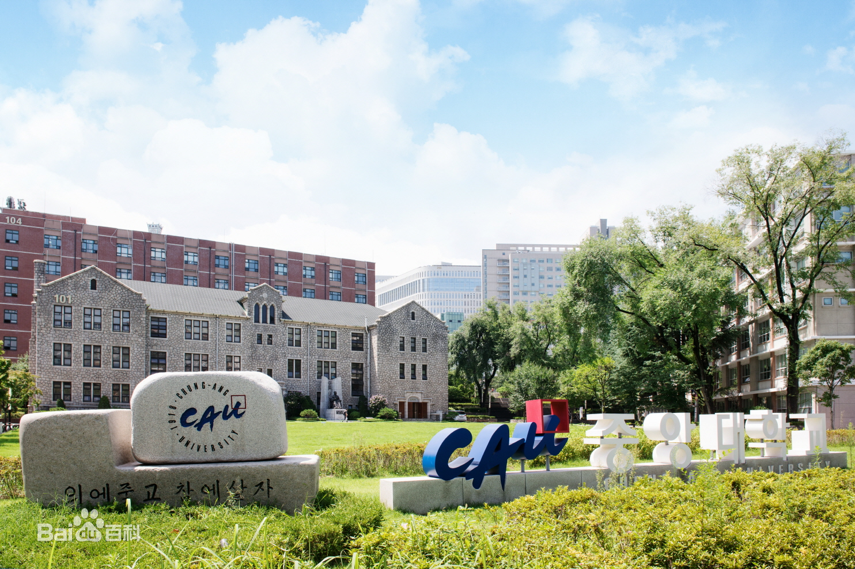
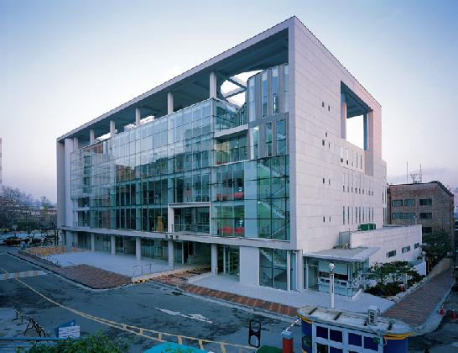

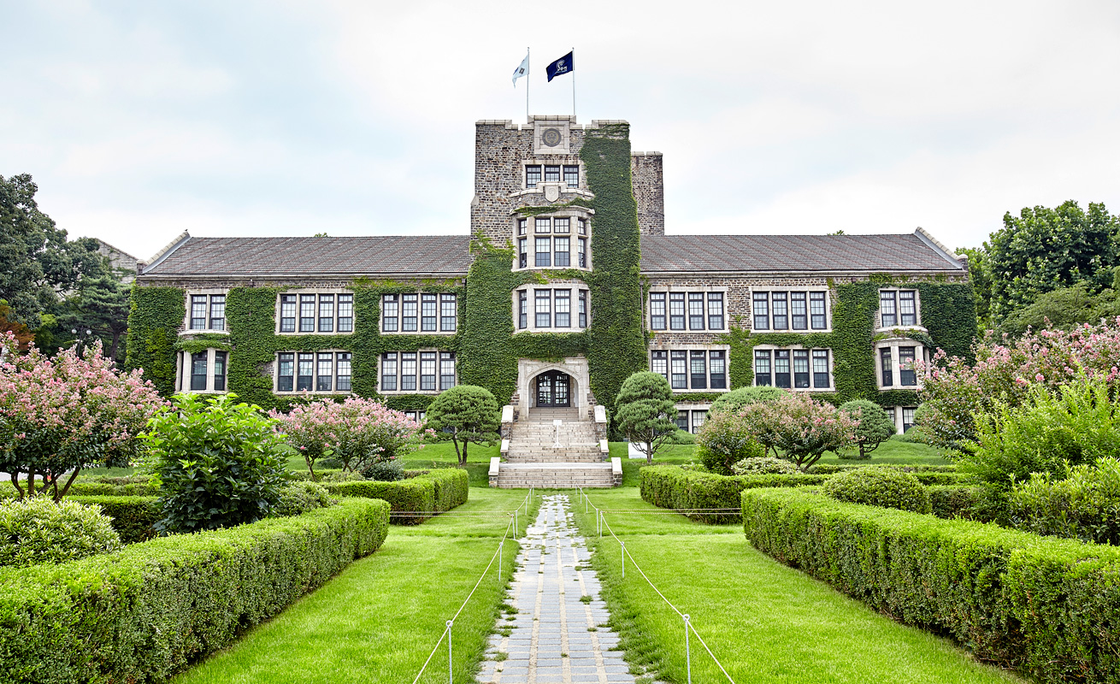

- 首尔科技大学 (http://en.seoultech.ac.kr/)
Seoul National University of Science and Technology
Introduction
The history of Seoul Tech can be dated back to the establishment of Public Eoeudong Vocational Continuing School on 15 April, 1910. Later in 1974, it was renamed as Gyunggi Technical College. As the revision of education law in accordance with regulations of establishment and operation in 1981, it was changed to Open University. Below is the number and statistics of the Seoul Tech:
- Campus size: 508,690 m2 (154,148 pyeong)
- Undergraduate schools: 7 colleges, 29 departments, and 1 division
- Graduate schools: 7 (1 general graduate school, 2 special graduate schools, and 4 professional graduate schools)
- Faculty and Staff: 773
- Students: 11,144

交换生项目申请
- 选拔对象：本科二年级学生
- 学习期限：一学期（8月至次年1月）
- 派出名额：两名
- 我校收取费用：暨南大学第三学年学费
- 绩点及综合测评要求：均排在本专业前30%

Exchange Programmes
Majority of courses are offered in Korean and 15% of courses are offered in English. List of courses taught in English for each semester will be available in the beginning of February or August. Please go to this website for more information:
http://global.seoultech.ac.kr/en/inbound/invitation/english/courses/

About the City
首尔，全称首尔特别市，旧称汉城。大韩民国首都，是世界第十大城市、朝鲜半岛最大的城市，亚洲主要金融城市之一；也是韩国的政治、经济、科技、教育、文化中心。
首尔位于韩国西北部的汉江流域，朝鲜半岛的中部。最早为周朝的真番东夷小国的栖居地，1394年朝鲜国王李成桂迁都汉阳并改为汉城。1948年起改称韩语固有词“서울”（首都的意思），成为朝鲜半岛唯一没有汉字名的城市。2005年1月，韩国政府宣布“서울”的中文翻译名称正式更改为“首尔”。
首尔全市下辖25区，面积约605.25 平方公里，是世界上人口密度极高城市之一。虽然首尔仅占韩国面积的0.6%，但其GDP却占全国GDP的21%。首尔是世界十大金融中心之一，世界重要的经济中心，消费者物价指数居世界第五。同时也是高度数字化的城市，网速和数字机会指数均居世界首位。
首尔也是一座年轻的城市，朝气蓬勃的人群、繁华喧闹的城市、迷人的自然景观、悠久的历史文化。充满活力的首尔到处呈现出令人心动的景象，拥有首尔大学、汉阳大学、成均馆大学等大专院校34所，是名副其实的大学之城。
首尔有冠岳山、三角山、仁旺山、景福宫、德寿宫、昌德宫等名胜古迹。市区内的浓荫下，古老的宫殿、庙宇等同直入云霄的现代建筑群交相辉映，显示了首尔既古老又现代的历史和时代风貌。
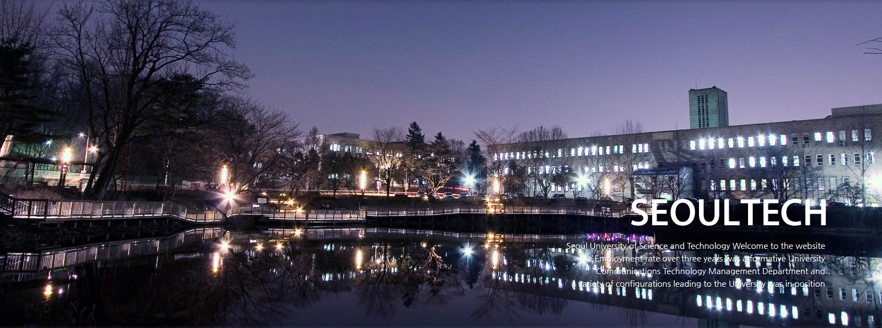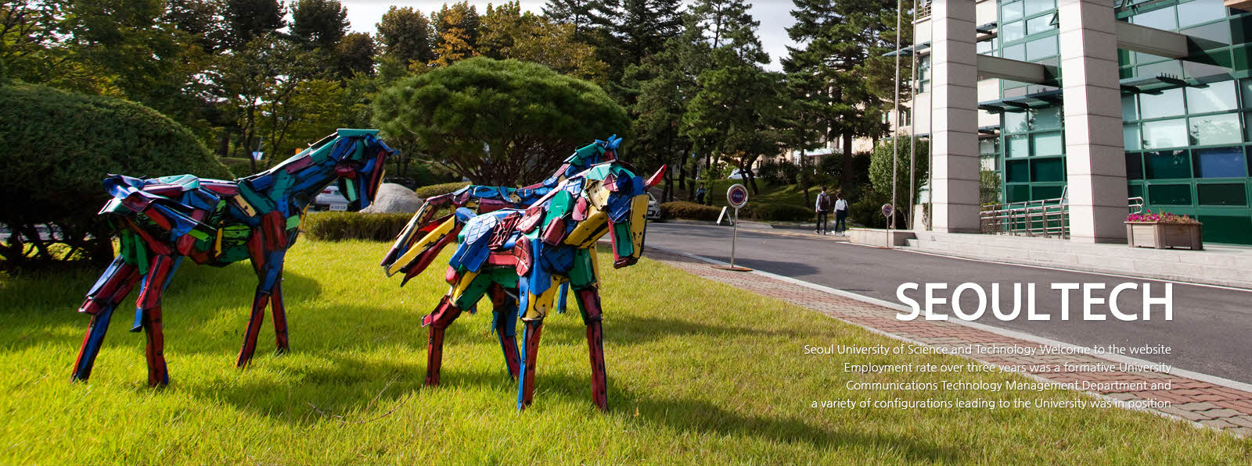
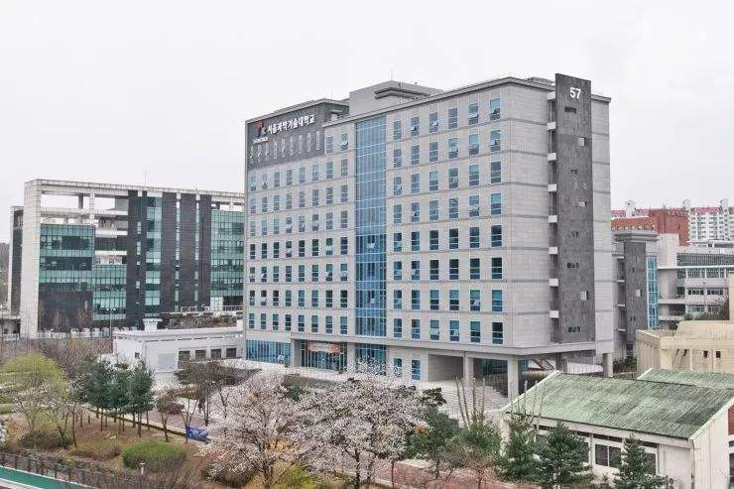

- 崇实大学

