法国
- Sciences Po Aix 艾克斯政治学院（https://www.sciencespo-aix.fr/）

Introduction
Since Sciences Po Aix was founded in 1956 as a public higher education institution, it has been committed to providing training to the highest standard and developing the analysis and decision-making skills of future executives in the private and public sectors. The school’s history has been marked by prestigious teachers and alumni who have risen to the highest positions nationally and internationally.
The historical Sciences Po Aix building is in the heart of Aix-en-Provence, in a private townhouse dating back to the 18th century, formerly home to the University of Provence, founded in 1409. The two other campus buildings are situated nearby and are also historical sites, including a former convent and beautiful gardens.
Sciences Po Aix is a Grand Ecole with admission by competitive exam or application, via a demanding selection procedure. It is a member of the Conférence des Grandes Ecoles, an organisation for France’s most prestigious academic institutions.
Sciences Po Aix offers professional training combining fundamental knowledge in social sciences (political science, economics and management, law, history, sociology, general knowledge, international relations, foreign languages), methodological training in decision-making and reporting, and training that develops students’ operational skills (group work, decision-making, choosing projects, business plans), all of which contribute to improving the employability of our graduates.
Courses are taught by a team consisting primarily of professors and lecturers who are leading authorities in their areas of expertise. This team includes a significant number of instructors from the business world who bring experience and a reputation that testifies to the quality of the knowledge they share with students.
艾克斯政治学院（Sciences Po Aix），全称普罗旺斯艾克斯政治学院（Aix-en-Provence Institute of Political Studies）成立于1956年，位于法国普罗旺斯地区的艾克斯市，属于法国的“大学校（Grande école）”之一，也是法国十所政治学院之一。
法国政治学院（IEP）体系培养了法国80%的政治家、90%的企业管理者以及几乎所有法语国家的总统、总理及部长，因而享誉欧洲乃至全世界，被誉为“法国社会精英的摇篮”。
AIX政治学院是法国政治学院体系中唯一的一所教育网络遍及地中海周边区域及国家的政治学院。埃克斯政治学院是典型的公立大学中的“大大学”，通过其杰出的文化理念，将不同的领域与企业，高级行政管理及研究相结合。

申请交换生项目
- 选拔对象：本科二年级学生
- 学习期限：一学期（8月至12月）
- 派出名额：两名
- 我校收取费用：暨南大学第三学年学费
- 绩点及综合测评要求：均排在本专业前30%

Programmes tailored to international students
Sciences Po Aix attracts international students from around the world who come to benefit from renowned courses on social sciences: Political Science, International Relations, Law, History, Media and Communication, Sociology, Anthropology, Foreign Languages… Nearly 300 foreign students spend a semester or a year here, further enhancing the multicultural dimension of our institution.
Hosting international students is central to our internationalisation policy and the consolidation of our international partnerships. We are constantly seeking to enhance our hosting services in order to facilitate the integration of these students by offering linguistic, educational and social support.
International students can therefore take classes designed specifically for them, including French as a Foreign Language (FLE), French civilization and methodology, and can also take classes designed for the French students, making for a rich academic exchange programme and a great experience.
Student tutors are specifically designated to assist foreign students with their studies by organising several tutoring and exam preparation sessions.

Student life at Sciences Po Aix
Student activities are a part of the everyday routine at Sciences Po Aix. Our students are creative, active, dynamic and involved in a wide variety of areas, from art to publishing, and from culture and politics to sports. They help make Sciences Po Aix not only a place of study, but also a vibrant centre of culture for Aix-en-Provence! The numerous clubs at Sciences Po Aix facilitate the integration of students according to their interests and offer opportunities to acquire genuine leadership skills.

Life in Aix-en-Provence
With a pleasant climate and over 300 days of sunshine per year, make the most of the charms of Aix-en-Provence, its streets and lively squares.
Here, history has set the scene for daily life, the pleasures of shopping, great cultural heritage, the delights of a terrace and architectural beauty, strolls through the city and Baroque masterpieces. Each fountain has its secrets and each private mansion its story, not to mention parks and gardens from through the centuries.
Aix-en-Provence is a canvas portraying joyful impressions in the hues of its celebrated artist, Cézanne, with colourful festivals and traditions, Provence markets, sunny delicacies, nature walks and liberating leisure activities. The historic town was founded in the days of the Roman Republic during the 1st century BC under the name Aquae Sextiae, in reference to its hot springs. Explore the pathways of history as you discover monuments, castles, chapels, oratories and architectural treasures.
Aix-en-Provence is home to exceptional heritage that is worth devoting several days to explore. It is also the ideal starting point for exploring the surrounding Provence region, with the most beautiful landscapes only a few kilometres away: Sainte Victoire Mountain, the rocky inlets of the Calanques, Camargue, Luberon and the Côte d’Azur.

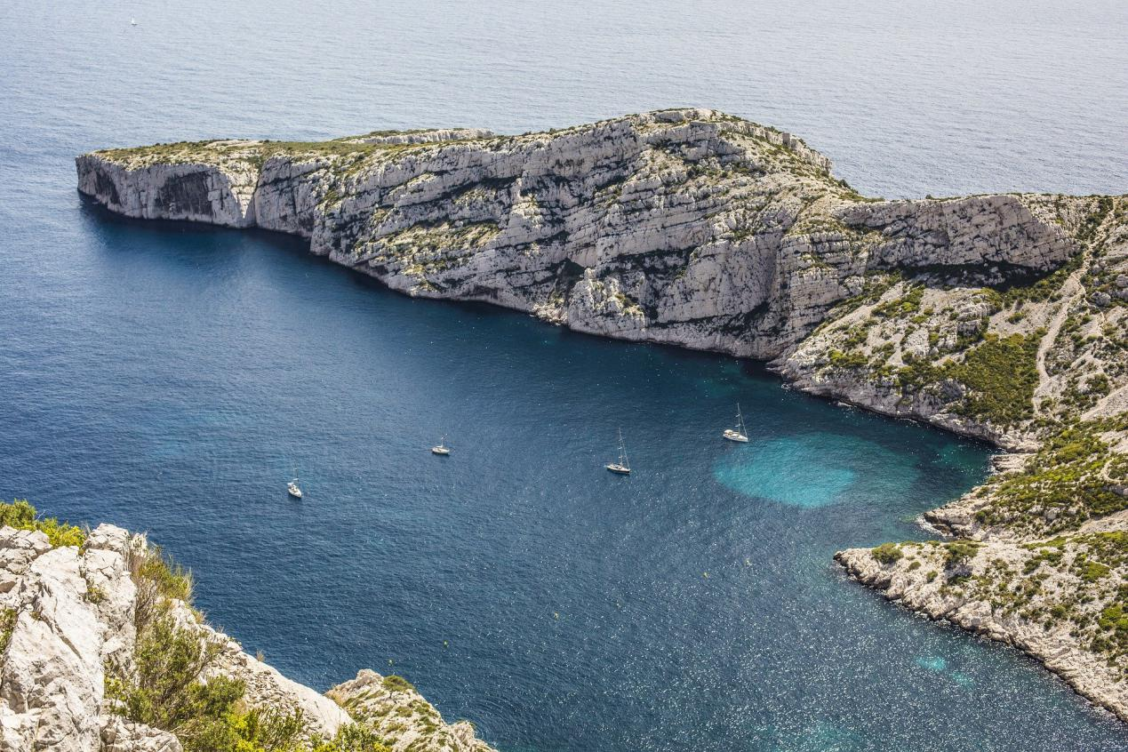

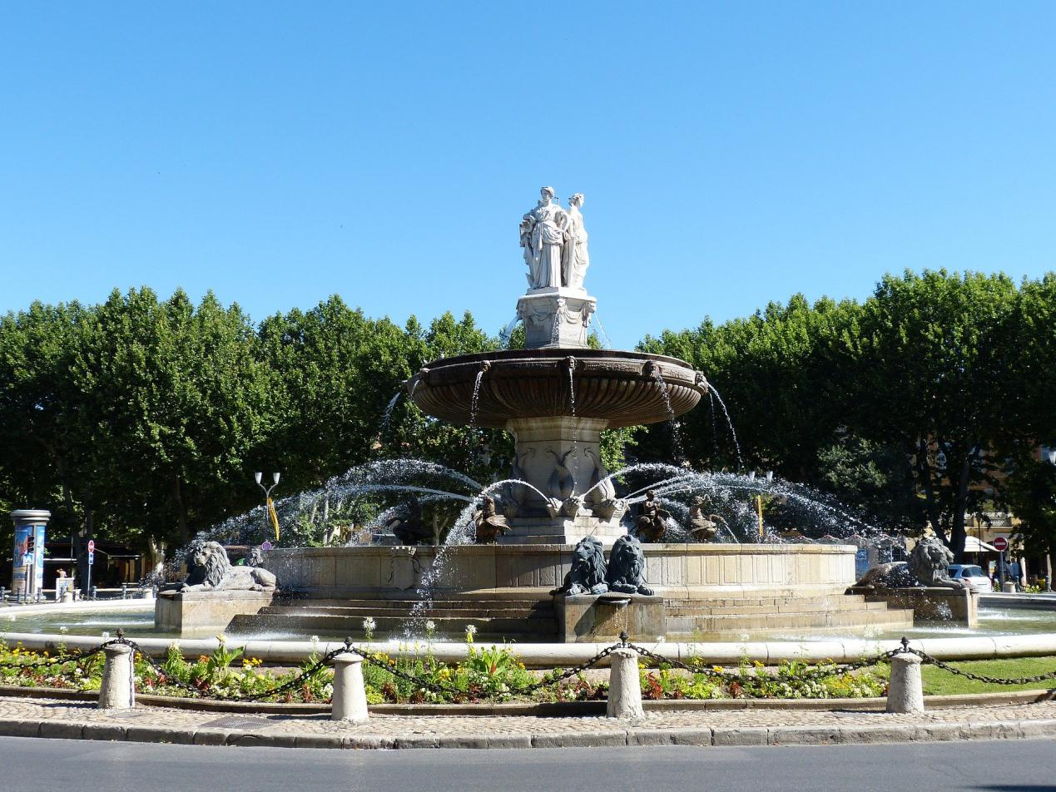

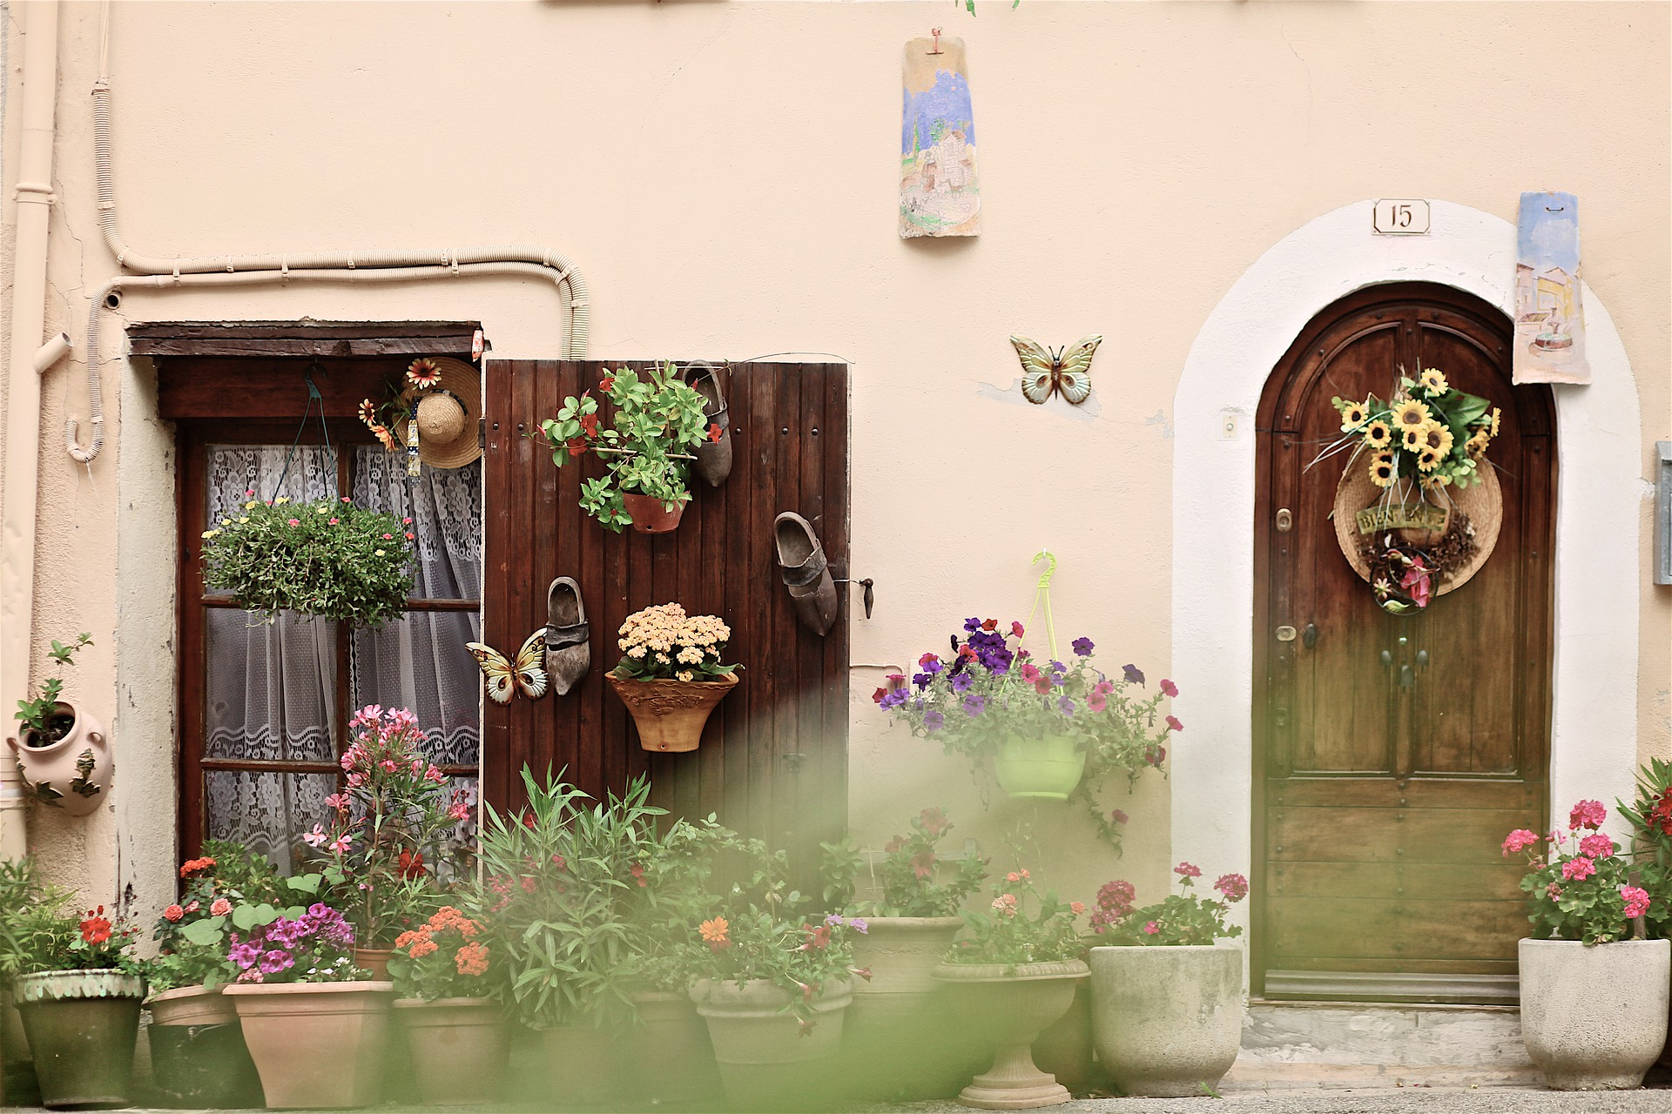

- Institut d’Etudes Politiques de Rennes 雷恩政治学院
(http://www.sciencespo-rennes.fr/fr/sciences-po-rennes.html)
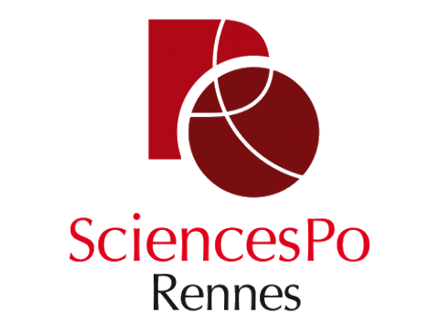

Introduction
Founded in 1991, Sciences Po Rennes is a public higher education establishment whose vocation is to train students from all over the population in jobs with responsibilities in the public, private and associative sectors. France as in Europe and in the rest of the world.
The professional opportunities are very varied. The multidisciplinarity which characterizes the training associated with an innovative pedagogy allow students to acquire specific knowledge and skills, recognized and sought after by companies, communities, associations ... in a world, a society in perpetual evolution .
Initial training, a five-year course, is based on a unique educational model. A multidisciplinary training of excellence in the field of human and social sciences (law, economics, history, political science) which allows to understand a wide variety of approaches and tools for analysis of the contemporary world, its challenges and transformations to become.
雷恩政治学院成立于1991年(法文惯用缩写"IEP de Rennes")，属于由法国国家政治科学基金会赞助的9所政治学院的网络成员之一（巴黎、斯特拉斯堡、波尔多、格勒诺布尔、里昂、图卢兹、艾克斯、里尔和圣日耳曼昂莱）。它和里尔政治学院一样，是法国最年轻的政治学院。
雷恩政治学院是一所社会科学,法学,经济学,历史学,管理学和政治科学领域的多学科高等教育机构。学校培养目标是为参加国立行政学院(ENA)及其它A类公务员著名行政竞考作准备。学院设有一个受国立行政学院认可的备考中心。学校规模不大，共有600名学生，23名大学教授和其他教员，此外还有相等数量的外部兼课教师。雷恩政治学院还拥有一个法国国家科研中心(CNRS)的合作研究中心-欧洲公共行动研究中心。此外，全体教员都从事个人研究活动,并发表高水平的学术作品。

交换生项目申请
- 选拔对象：本科二年级学生
- 学习期限：一学期（8月至12月）
- 派出名额：两名
- 我校收取费用：暨南大学第三学年学费
- 绩点及综合测评要求：均排在本专业前30%

Programes for International Students
One of the characteristics of Sciences Po Rennes is the place accorded in its strategy and its educational project to international openness. This is characterized in different ways:
- By the school's desire to open its students to the realities of the contemporary world through the learning of two compulsory modern languages (plus a third optional), the recognition at European level of the training provided at Sciences Po Rennes (the equivalence of diplomas is ensured by the ECTS credit system).
- By the existence of an integrated Franco-German curriculum from 1st to 5th year in partnership with the Catholic University of Eichstätt-Ingolstadt.
- Through the Chinese World Course program (specific lessons, training and diploma).
- Finally and above all by a compulsory stay of one year abroad, either in university, or as part of an internship. Sciences Po Rennes is today bound by bilateral cooperation agreements with more than 140 universities in around forty countries spread over five continents. The institute is also a member of networks such as Erasmus for Europe, International Student Exchange Program for the USA, Institute of the Americas for the Americas.
Sciences Po Rennes welcomes each year around one hundred foreign students for two semesters or one. They have the choice between two programs:
- The program in French to obtain the Certificate of political studies at the end of a year of study or the Attestation of political studies if they stay only one semester.
- The program in English to obtain the Diploma of political studies in English at the end of a year of study or the Certificate of political studies in English if they stay only one semester.

The Caen Campus
Since 2012, the Caen Campus of Sciences Po Rennes offers through its privileged environment on a human scale and its strong territorial anchorage, training in professional fields in full development with a focus on innovation, anticipation and 'internationalization.
The establishment is located at 10 rue Pasteur, in buildings completely renovated for the occasion, with an interior courtyard and an urban garden. As in Rennes, the premises are located in the heart of the city center, a few meters from the Place Saint-Sauveur and the Abbaye-aux-Hommes. This location thus allows students to take full advantage of the charm of the places and the many events offered by the city (Les Boréales festival, student carnival, book fair, etc.). In the heart of an agglomeration of 265,000 inhabitants, Caen has a rich economic, cultural, associative and sporting environment.
The Caen Campus offers teaching focused on understanding, driving and supporting transitions. Our students are mainly oriented towards the fields of consultation, dialogue, foresight, urban planning or renewable energies, with a view to managing projects and territories.
These are fields of the future, both in terms of professions, professional opportunities, research, inter-regional cooperation and public policy, which are approached under a multidisciplinary approach, which is the strength of the "Sciences Po" model.
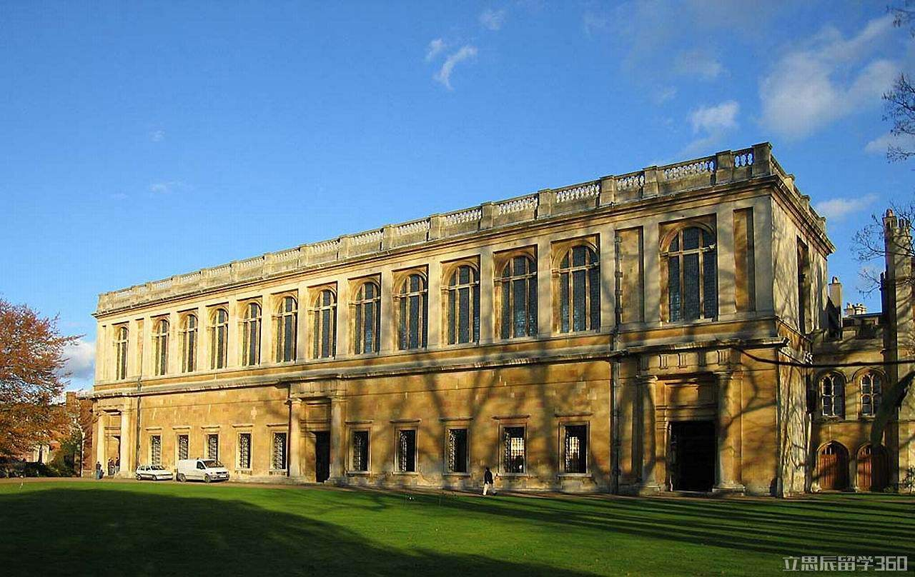
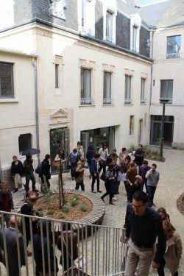
- The Catholic University of Lyon里昂天主教大学
(https://www.ucly.fr/en/)
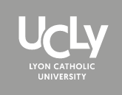

Introduction
The Catholic University of Lyon was founded in 1875 and combines respect for Christian heritage with a spirit of openness.
With its location at the heart of the regional capital, its close ties to business and strong international links, it seeks to promote academic excellence, creativity and integrity.
UCLy's 6 faculties:
- Legal, Political and Social Sciences
- Economic Sciences and Management
- Natural Sciences
- Literature and Languages
- Theology and Religious Sciences
- Philosophy and Human Sciences
The Catholic University of Lyon is a member of the University of Lyon.

The Catholic University of Lyon has :
- 6 faculties with undergraduate and postgraduate courses
- 5 professional schools of higher education
- 26 education and research units
- 12500 students and auditors, including 2800 international students
- 200 permanent lecturers
- 460 administrative and technical staff
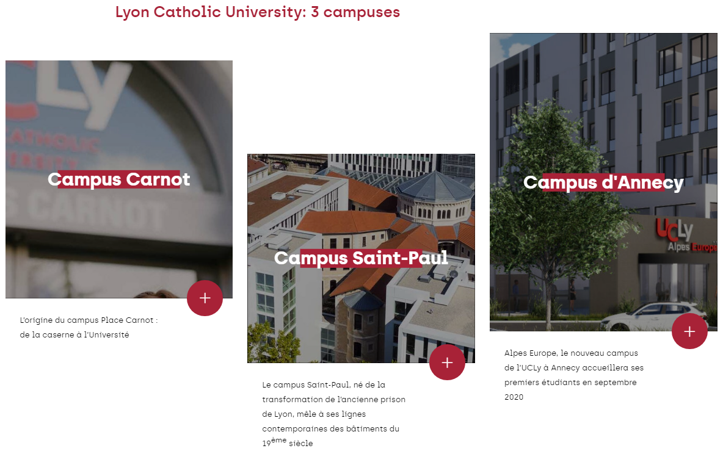
里昂天主教大学建于1875年，是一所综合性的文理科大学。拥有五个学院，五个高等专科学校，二十个研究中心和两个附属大学。专业涉及经济、工程、生物、建筑、语言、文学、历史和管理等，基本覆盖所有文理科专业，里昂天主教大学的优势学科是语言类专业。
该大学于1948年成立了评议文化学院，具有50多年丰富的对外留学生教学经验。学校拥有5个学院、5个职业学校、20个研究所和研究中心，并在第戎、马赛和尼斯和尚贝里设有大学附属单位，学校有很大的国际影响，与五大洲的大学交流学生、教师和科研人员，尤其与发展中国家有着源远流长的特有关系。

交换生项目申请
- 选拔对象：本科二年级经管类学生
- 学习期限：一学年（8月至次年5月）
- 派出名额：两名
- 我校收取费用：暨南大学第三学年学费
- 语言要求：雅思6.0分或托福80分
- 绩点及综合测评要求：均排在本专业前30%

Programmes for Exchange Students
Exchange students at UCLy can take up to 2 classes in each Department out of their Department of enrolment, provided the selection of courses has been validated by their Home Institution Academic Advisor and the course schedules are compatible. In case of schedule conflicts, the Department of enrolment will invite the exchange students to choose their courses within said unit.
Please see the website below to find more information:
https://www.ucly.fr/wp-content/uploads/2020/03/english-courses_catalogue_2019-2020.pdf

Life in Lyon
Greater Lyon is one of Europe's major economic and cultural metropolises. Lovers of large, unspoilt urban spaces can enjoy a green city that has reclaimed its banks, a city where pedestrians, cyclists, and trams share space, a city that brings the countryside to the heart of neighbourhoods undergoing reconstruction.
A city of the past, attached to its traditions, and its communities, Lyon is also a fashionable city, a city of creators, which gives it strength and charm. A city where the art of living is more "art" than livestock, just in case you still picture quaint country cottages with chickens roaming outside. Lyon is a city where young chefs are kings.
Capital of the Gauls under the Roman Empire, a great cultural and commercial city during the Renaissance, a powerful industrial city in the 19th century, Lyon became a great European metropolis by integrating all the influences that inspired it.
Reflecting the different eras, Lyon's rich heritage tells the story of the city, from antiquity through the Renaissance and to the contemporary era.
The entire city centre is listed as a UNESCO World Heritage Site, making it the largest listed urban area in the world (500 hectares).

