美国
- 诺维奇大学 Norwich University (https://www.norwich.edu/)
Introduction
Norwich is one of the exceptions and in a very substantial sense the institution today is the lengthened shadow of its founder, Captain Alden Partridge. It was founded in 1819.Norwich University comprises five colleges: the College of Graduate and Continuing Studies, the College of Liberal Arts, the College of National Services, the College of Professional Schools, and the College of Science and Mathematics. You will find much interdisciplinary thought and dialogue among our colleges. We invite you to explore what each has to offer and discover the contribution you want to make to the evolving discussions.
Norwich University’s campus is nestled in the Green Mountains of central Vermont, USA. Montpelier, the state capital, is about a half hour from the university, and Boston, New York, and Montreal are just a few hours’ drive. The Northfield campus is small, safe, and community-oriented. This year, Norwich is home to students from 40 states and 38 countries from across the globe.

交换生项目申请
- 选拔对象：本科二年级学生
- 学习期限：一学期（8月至12月）
- 派出名额：两名
- 我校收取费用：5万元保证金、暨南大学第三学年学费
- 语言要求：雅思6.0分或托福80分
- 绩点及综合测评要求：均排在本专业前30%

Exchange Students
Norwich also offers you a group of friendly, full-time staff to assist you at our International Center as well as personalized tutoring at our Academic Achievement Center. Our small size allows you to gain close relationships with faculty, staff, and fellow students. For more information, please check the website:
https://www.norwich.edu/admissions/international

About the City
Norwich University位于美国佛蒙特州北田市。佛蒙特州是美国东北部新英格兰地区的一个州。南邻马萨诸塞州，西连纽约州，北与加拿大魁北克省接壤，东与新罕布什尔州以康涅狄格河为界。首府蒙彼利埃。州名来自法语“Monts Verts”，意为“绿色山岭”。佛蒙特州别名“绿岭之州” “Green Mountain State”。首府蒙彼利埃名称也来自法国同名城市。佛蒙特以其美丽的景色、奶制品、枫糖浆和激进的政治而著称。
气候特征冬长夏短，温度和降水量因地势高低而有很大差异。谷地冬季雪量一般平均1700～2000毫米，山区则高达2800毫米，东部和西部的降水量为860毫米，山区达1000毫米。气温在冬季可降至－34℃以下，夏季很少超过32℃。除尚普兰谷地生长期较长外，其他地区生长期仅120天左右。九月份开始有初霜，终霜可延迟到翌年六月一日。
佛蒙特州的春季短促多雨，夏季凉爽，秋季多色，冬季非常寒冷。尤其北部异常寒冷，往往比同州南部地区冷十度。佛蒙特州是美洲东海岸地区的滑雪圣地。 秋季，佛蒙特州的山丘被糖枫树叶染成红色、橙色和金色。这些不同的颜色不是由不同的树种形成的，而是由不同的土壤和气候导致的。

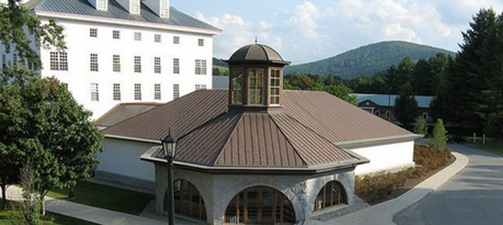
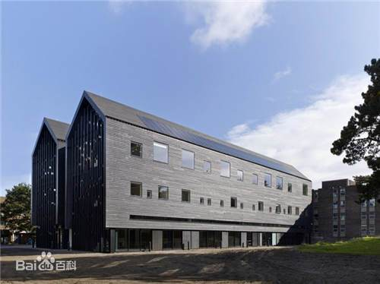

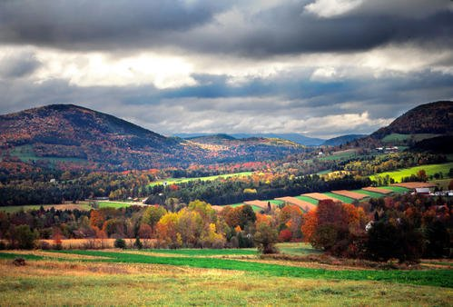

- 柯伊学院 Coe College (https://www.coe.edu/)

Introduction
Coe College is a selective, private, nationally recognized four-year liberal arts college providing superior educational experiences for students since 1851. Coe's residential campus is located in Cedar Rapids - Iowa's second largest city - and only hours from several major metropolitan hubs like Chicago, Minneapolis, Omaha and St. Louis. The 1,400+ students enrolled at Coe make up a diverse population, representing nearly 40 states and over 20 foreign countries. A focus on small class sizes and faculty interaction provide a personal learning atmosphere for each student. The Coe Promise guarantees 100% of students will complete an internship, research project or off-campus study experience before graduation. Coe is consistently listed as a top academic institution by U.S. News & World Report, has an established Phi Beta Kappa chapter and is a top producer of Fulbright Scholars.

交换生项目申请
- 选拔对象：本科二年级学生
- 学习期限：一学期（8月至12月）
- 派出名额：两名
- 我校收取费用：5万元保证金、暨南大学第三学年学费
- 语言要求：雅思6.0分或托福80分
- 绩点及综合测评要求：均排在本专业前30%

International Students
Coe College students exercise the ability to appreciate the ethnic and cultural diversity that makes up our residential campus and surrounding community. As an international student at Coe, you will be welcomed by over 80 international peers from countries such as China, Japan, Nepal, Vietnam, Germany and India.
For more detailed information, please go the website:
https://www.coe.edu/application/files/5715/3789/1898/international-guide.pdf

About the City
爱荷华州（艾奥瓦州），是美国50个联邦州份之一，其首府为得梅因（Des Moines）。爱荷华州位于美国中西部地区，20世纪中后期，爱荷华州的农业经济过渡到多元化经济，械造业位居全美各州首位。如高级制造业，金融保险，生物技术和绿色能源产品等。该州区居民的平均受教育程度全美领先，超过9成以上常住人口具有大学教育背景，爱荷华州被列为美国居住最安全的州之一。爱荷华的州民被昵称为“千里眼”（Hawkeyes）。
艾奥瓦州在行政区位上，艾奥瓦州北接明尼苏达州，西边与内布拉斯加州与南达科他州相邻，南接密苏里州，东邻威斯康辛州与伊利诺州。介于密西西比河与密苏里河之间，除西北一隅地势较高外，绝大部分地区为坦荡开阔的平原。
爱荷华州的公共教育位居美国之首，该州注重教育并历史上占有重要的角色，由国家考试可见一斑。2003年爱荷华州的SAT考试平均成绩为全美第二高分，并在超过20%的毕业生参加测试的SAT平均成绩亦为全美第二高分。ACT试务中心位于爱荷华市，ITBS与ITED试务系统由爱荷华大学建构。

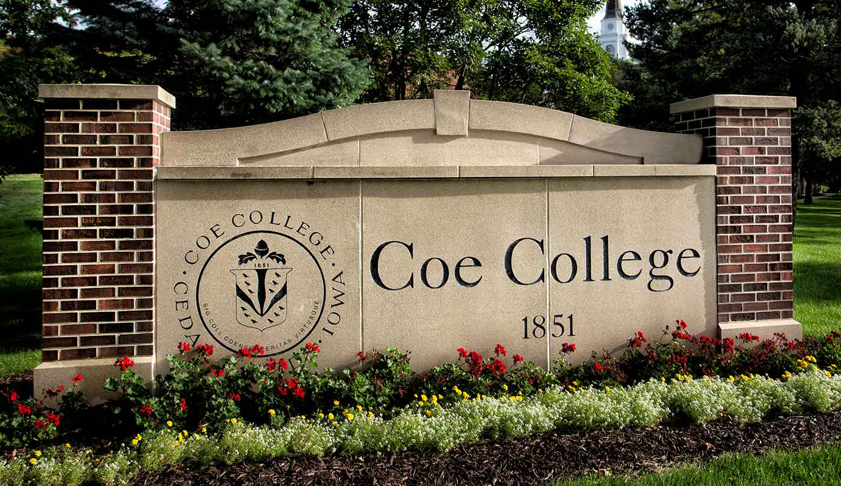
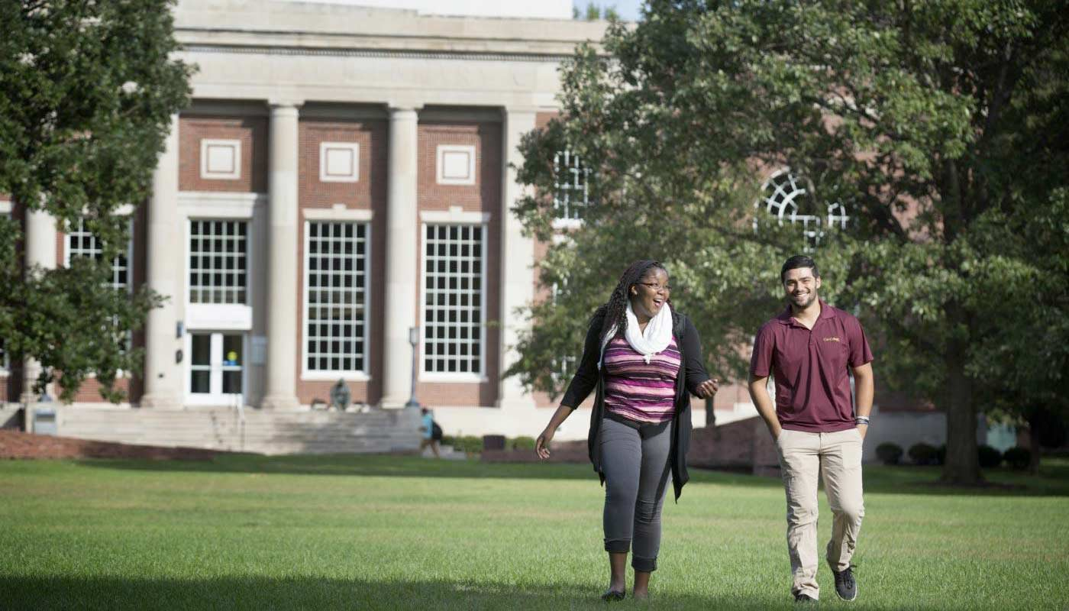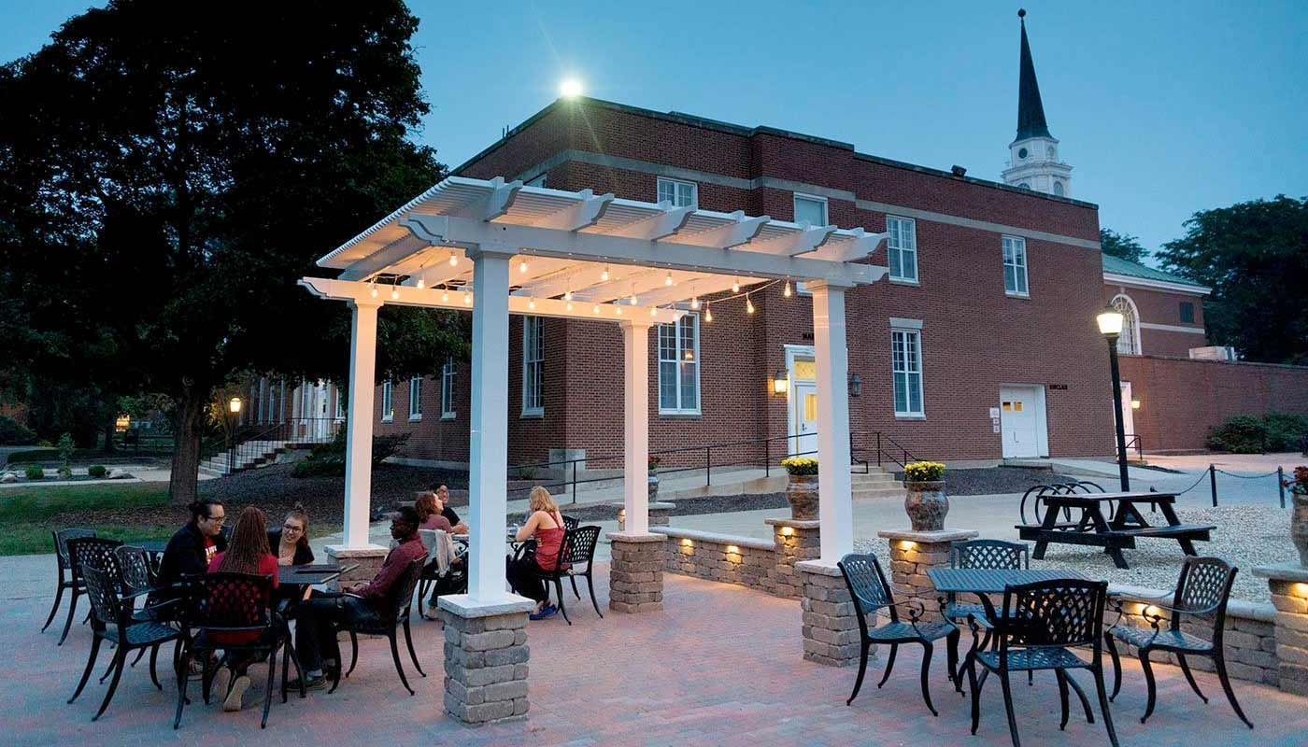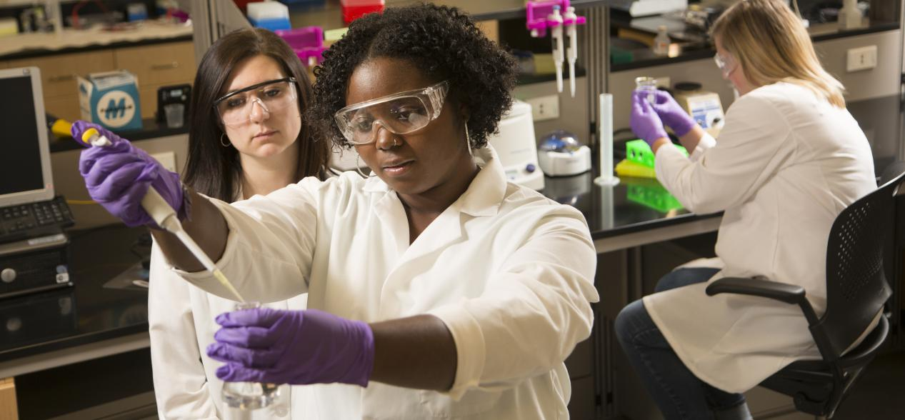

圣道大学 University of the Incarnate Word (https://www.uiw.edu/)
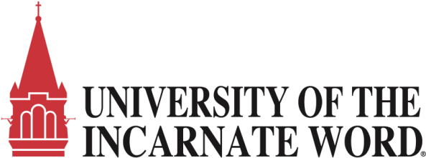

Introduction
The Mission of the University is derived from the history of its founders, the Sisters of Charity of the Incarnate Word, who came to San Antonio in 1869, shortly after the close of the Civil War. In 1893, the Sisters established Incarnate Word School on Government Hill in San Antonio.
UIW offers over 90 undergraduate majors, minors and concentrations, and over 25 graduate and doctoral programs — each designed with input from industry leaders and top employers. UIW stands as the largest Catholic university in Texas, and among the nation’s most diverse and welcoming faith communities.

交换生项目申请
- 选拔对象：本科二年级学生
- 学习期限：一学期（8月至12月）
- 派出名额：两名
- 我校收取费用：5万元保证金、暨南大学第三学年学费
- 语言要求：雅思6.0分或托福80分
- 绩点及综合测评要求：均排在本专业前30%

Exchange Students
UIW welcomes students from over 140 Sister Schools to participate in the UIW Exchange Program. Exchange students from a Sister School may apply to study at UIW for up to two semesters. Exchange students must be nominated by their university prior to submitting their application and supporting documents. For more information:
https://www.uiw.edu/studyabroad/incoming-students/index.html

About the City
得克萨斯州，简称得州，是美国南方最大的州，也是全美第二大州，仅次于阿拉斯加州。州名来自于印地安Hasinai族中的Caddoan语“tejas”，意味着“朋友”或是“盟友”。西班牙的探险家在命名得州时将这个本应该为人称的词误以为地名，就由此沿用下来。
首府为奥斯汀。休斯敦是得州第一大、全美第四大城市，大休斯敦地区则是全美第五大都会区。达拉斯-沃思堡都会区是得州最大、全美第四大都会区。圣安东尼奥是得州第二大、全美第七大城市。
得州以能源和石化工业著称，是美国最大的能源和化工州。石油和天然气产量分别占全美产量的1/3和1/4，炼油能力占全美1/4强。20世纪80年代开始，得州推行经济多元化政策，虽然石油和天然气仍是得州的主要工业，但所占比重已经下降，高科技产业发展迅猛，休斯敦、圣安东尼奥和达拉斯三角区已成为美国第二个“硅谷”，休斯敦地区已发展成为全美乃至全球最大的医疗培训和治疗中心。休斯敦、达拉斯－福特沃斯、圣安东尼奥与奥斯汀走廊和得克萨斯与墨西哥边界成为全美人口增长最快的都市区。得州科研机构在能源化工、医疗卫生、航空航天、生物、农学、电子和新材料等领域科技优势突出。

