巴西
圣保罗大学 Saint Paul University (https://www5.usp.br/)
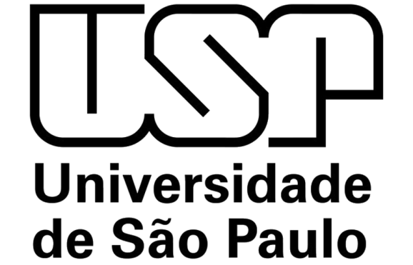

Introduction
University of São Paulo is one of the largest and most important institutions of higher education and research in Brazil and Latin America. Founded in 1934, USP is a public state institution (it does not charge tuition fees) and has campus placed in eight cities spread throughout the state of São Paulo. With education and research activities in all academic fields, USP offers 183 undergraduate programs, 269 graduate programs (both Master's and Doctoral (PhD) degrees) and 984 extracurricular programs. In total, there are about 90 thousand students enrolled in 48 Schools (faculties and institutes) which make up USP. Furthermore, the university houses important museums which receive over 1million visitors per year. In addition, USP runs health centers and two major hospitals. It also works in partnership with Hospital das Clínicas of Ribeirão Preto and Hospital das Clínicas of São Paulo, the later considered one of the leading hospitals in Latin America. Over 87% of the more than 5,600 professors are full time employees. This reinforces the university’s commitment to achieving excellence in terms of its personnel and of generation of knowledge.

交换生项目申请
- 选拔对象：本科二年级学生
- 学习期限：一学期（8月至次年1月）
- 派出名额：两名
- 我校收取费用：暨南大学第三学年学费
- 绩点及综合测评要求：均排在本专业前40%

International Students
Universidade de São Paulo (USP) offers a number of exchange places for students from partner universities from all around the globe. You can apply for the international exchange programme if you are currently enrolled in your first year (or above) of study at a university that has an international exchange agreement with USP. Here is more detailed information: http://www.usp.br/internationaloffice/en/index.php/admissions/studentexchange/exchange-student

About the City
圣保罗（São Paulo）位于巴西东南部圣保罗州，是圣保罗州的首府、巴西最大的城市，也是南美洲最大最繁华的城市、世界著名的国际大都市。圣保罗于1554年1月25日建市。2012年，美国的SinkTank公开发表按照产业、人才、文化、政治等方面来综合计算世界都市排名，圣保罗位居全世界第33位，更有机构给予世界第12位的高评价。而里约热内卢次之。
圣保罗既为巴西最大的经济城市，亦为南北物流重镇，道路四通八达。然而，车辆过多、交通堵塞等问题，给城市运行造成一定程度困扰。同时圣保罗是仅次于纽约及东京的直升机运输量第三大城市。
圣保罗是巴西最大的工业城市，城市工业的形成和发展同圣保罗州的经济密切相关。公元19世纪以前，圣保罗州盛产棉花、稻米和咖啡，所以作为州首府的圣保罗市的工业以棉纺、粮食加工、咖啡加工的传统工业为主。后来，逐渐发展了冶金、机械、汽车、电力、食品、水泥、化学、橡胶、烟草、造纸等工业，而这些工业部门能够大力发展的主要原因是城市附近有丰富的水力资源，工业原料的大部分可从圣保罗州及附近地区获得。近二三十年来，圣保罗又建有巴西电子工业中心、汽车工业基地和全国最大的炼油厂。
圣保罗因地势比较高，属热带高原性气候，气候温和。夏季从10月至3月，多雨凉爽；冬季从6月至8月，干燥偏冷，无严寒，只有最南端的一小部分会下雪。圣保罗降雨集中在12月至3月，昼夜温差比较大。

