智利
- 智利大学 Universidad de Chile (https://www.uchile.cl/)
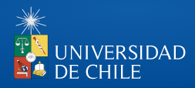
Introduction
The University of Chile was founded on the 19th of November, 1842. It is the oldest higher education institution in Chile. Generating, developing, integrating and communicating knowledge in all the areas of knowledge and culture are the mission and basis of the activities of the University. The University is located in the capital city Santiago de Chile and it is a public university with international quality. All the areas of knowledge are elaborated in their lecture halls and today the university is at the top of the Chilean university system with regard to teaching, research, creation and outreach.
The university is distributed in five campuses and several experimental stations in Santiago and other Regions of Chile: 14 Faculties and 5 Interdisciplinary Institutes.
The University of Chile has 42.636 students (2018) with 33,572 undergraduate students and 9,064 graduate students. 20 Chilean Presidents have been students of the University of Chile (61% of the total). Also, the two Chileans who received the Nobel Prize, Gabriela Mistral (1945) and Pablo Neruda (1971), both in Literature, were members of the University.
It is placed among the 401-500 best higher educational establishments in the World Ranking of Universities (University Shanghai Jiao Tong, 2019).

交换生项目申请
- 选拔对象：本科二年级学生
- 学习期限：一学期（8月至次年1月）
- 派出名额：两名
- 我校收取费用：暨南大学第三学年学费
- 绩点及综合测评要求：均排在本专业前40%

For International Students
The Universidad de Chile offers international visiting students freedom to select their courses of studies, according to previous academic experience and ability to work in Spanish, allowing them to request registration in any course offered during their stay.
Courses may include subjects in the natural sciences, engineering sciences and technology, agriculture, pharmacy, forestry sciences, chemical sciences and technologies, environmental sciences, veterinary sciences, social sciences, economics and management, political science, international studies, law, fine arts, music, architecture and urban planning, design, geography, languages and literatures, and humanities.
For more information, please visit:
https://www.uchile.cl/portal/english-version/international-visiting-students/49754/student-mobility-program

Information about Chile
- Location: south-west South-America
- Surface (continental and insular): 756,247 km2
- Capital: Santiago
- Type of Government: Representative Democracy, Presidential Regime, Law State
- Total population of Chile: 17.574.003 (Instituto Nacional de Estadísticas (INE) 2018)
- Official language: Spanish
- Official currency: Peso (for its equivalence see: www.bcentral.cl)
- Borders
Chile borders in North with Peru, in the East with Bolivia and Argentina, and in the West with the Pacific Ocean and in the South with the South Pole.
- Climate
Because of it topography and its length from north to south, Chile has a great variety of climates. Barren from Arica to La Serena, Mediterranean in the central region until Concepción, tempered rainy from Concepción to Punta Arenas and the polar ice of Antarctica.
- Most important cities
The most important cities apart from Santiago are: Antofagasta, Concepción, Temuco, Valparaíso/Viña del Mar (main port of the country), and Puerto Montt.
- Transport
In the capital city Santiago there is a wide network of public transport through taxis, microbuses or micros. It also has a wide underground network Metro (with six lines). For national trips there are local airlines and very good buses from the capital city to most of the destinations in the country. At the International Airport of Santiago "Comodoro Arturo Merino Benítez", at 20 km. of the city, there are minibuses, buses and taxis to get to the city.

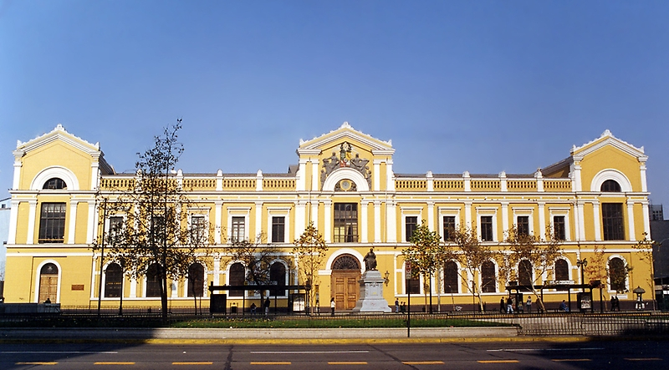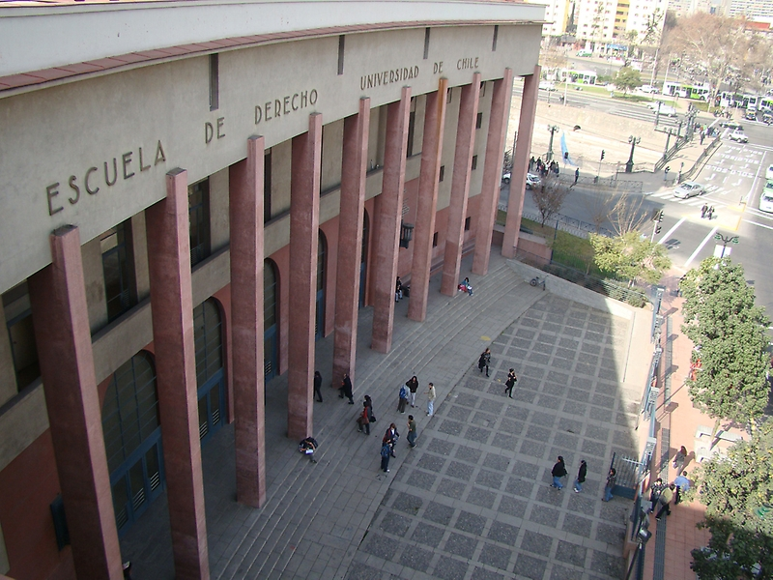

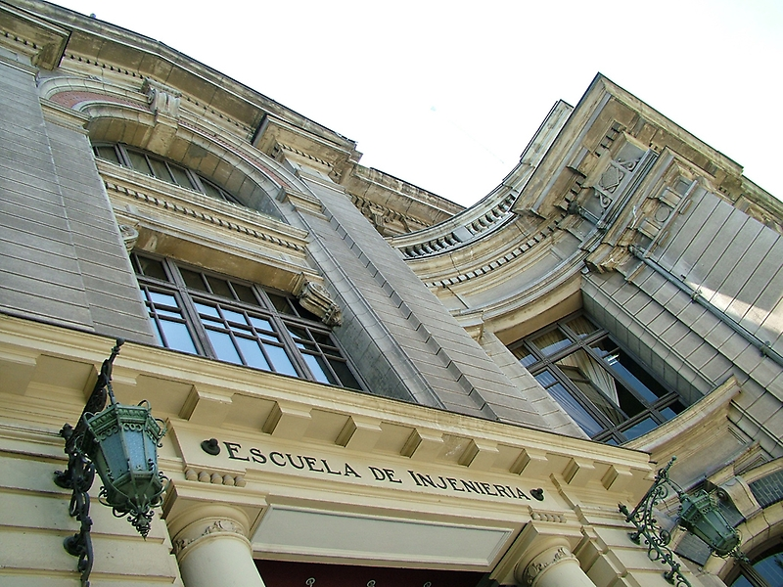

- 智利边境大学 Universidad de la Fontera
智利边境大学成立于1981年，由原智利大学特木科校区和国家技术大学合并而成，是一所的传统公立大学。该校位于南部阿劳卡尼亚大区，该大区为原住民马普切人聚集区，当年西班牙殖民者来到这里,遭到骁勇善战的马普切人顽强抵抗，被迫与其签署协议，划定边界，该校名称即来源于此。
智利边境大学坐落于智利阿劳卡尼亚区，是一所卓越的区域性大学。学校以培养专业人员和研究生为使命，旨在通过知识产出与传播以及文化艺术的熏陶，培养出勇于创新、兼容并济、对地区和国家发展有贡献的高素质人才。
智利边境大学在校长理事会大学成员中位列A类，连续6年在管理、教学、科研及社区活动参与度等领域得到社会广泛认可，这使其成为智利南部和极南地区唯一一所地区性州立高等教育学府。学校在38年的发展历程中，受法律保护与制约，凭借卓越表现成为区域性大学的模范院校。
边境大学主校区位于特木科市，在普孔市、安格尔市建有分校区。下设农林科学学院、教育与人文社科学院、法律与商业学院、工程与科学学院、医学院、牙医学院等学院；农用工业、本土研究、区域发展、教育应用计算机科学等研究所。计有本科专业45个、硕士专业28个、博士专业10个，以及专科教育35个；在校学生9400人，其中马普切人占40%左右。现任校长爱德华多·赫贝尔·卫斯（EDUARDO HEBEL WEISS）2018年6月当选。
该校重视与中国的合作交流，自2013年起开设汉语选修课程，由国家汉办派出志愿者教师任教。该校与中国驻智利使馆关系密切,近年来多次接待中国文艺团组和展览，为当地民众增进对中国的了解起到了积极作用。
