英国
- University of Birminghan伯明翰大学
(https://www.birmingham.ac.uk/index.aspx)
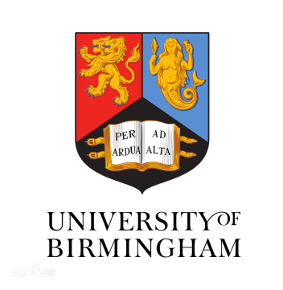

Introduction
Birmingham has been challenging and developing great minds for more than a century. Characterised by a tradition of innovation, research at the University has broken new ground, pushed forward the boundaries of knowledge and made an impact on people’s lives. We continue this tradition today and have ambitions for a future that will embed our work and recognition of the Birmingham name on the international stage.
More than a century after the University of Birmingham was established to unlock the global potential of a progressive city, we remain committed to ensuring our national and global influence while remaining at the heart of the city’s renaissance. Our campus is home to a wealth of historical, scientific, cultural and sporting assets open to our community. We welcome you to visit, be inspired, entertained and expand your knowledge.
伯明翰大学（University of Birmingham）始建于1825年，是位于英国第二大城市伯明翰的世界百强名校，英国顶尖学府。于1900年获得维多利亚女王授予的皇家特许状，是英国著名的六所“红砖大学”中的首位成员，英国12所精英大学之一。同时也是英国常春藤联盟“罗素大学集团”核心成员，M5大学联盟成员，国际大学组织“Universitas 21”创始成员，中英大学工程教育与研究联盟成员。 2017/2018年QS世界大学排名位居世界第84位（历年最高62）。在2017年英国官方组织的教学卓越框架（TEF）评估中，居全英第3名。在TIMES英国大学专业排名中，物理和天文专业第2，化学工程专业第4，计算机科学专业第5。 伯明翰大学被《星期日泰晤士报》和《泰晤士报》评为2013-2014“年度大学”。
此外，伯明翰大学商学院是英国高等教育中最早建立的商学院，获得AACSB、AMBA和EQUIS三大认证的世界1%顶尖精英商学院。同时伯明翰大学在医学和生物科学领域颇为强势，其中，生物科学专业方向就业率仅次于剑桥大学。伯明翰大学建校一个多世纪以来，凭着高质量、多领域的研究得到世界的认可，英国首相斯坦利·鲍德温、内维尔·张伯伦和罗伯特·安东尼·艾登，诺贝尔奖得主质谱仪的发明者弗朗西斯·阿斯顿，以及中国近代地质学之父李四光，两弹一星元勋姚桐斌，中国金属物理、冶金史学科奠基人柯俊等都是伯明翰大学的杰出校友。截止至2017年底，从伯明翰大学已经走出了11位诺贝尔奖得主，3名英国首相，5名外国政府首脑。

交换生项目申请
- 选拔对象：本科二年级学生
- 学习期限：一学年（9月至次年6月）
- 派出名额：两名
- 我校收取费用：暨南大学第三学年学费及对方学费约12,000英镑
- 语言要求：雅思6.5分且单科不低于6分
- 绩点及综合测评要求：均排在本专业前30%

Programmes for International Students
Birmingham is a truly global university producing world-leading research. We benefit from mutual partnerships with a wide range of international institutions and host a large international community of researchers and students. With over 8,700 international students from approximately 150 countries, and 31% of our academic staff from overseas, our campus is truly a diverse and global place which attracts the brightest and best international students and staff.

Birmingham the city
In the glorious heart of England, Birmingham is a diverse, modern and exciting city with a long cultural and intellectual heritage.
Less than two hours from London, Birmingham is situated in a prime, central location in the country, and offers everything you could desire from a capital city, within easy reach of the picturesque English countryside.
Catch the train from University Station to Birmingham New Street in eight minutes.With Birmingham International Airport on your doorstep, travelling to mainland Europe couldn't be easier.
Birmingham is the youngest city in Europe, with under-25s accounting for nearly 40% of its population.With over 8,000 acres of parks and open space, Birmingham is one of the greenest cities in the UK. All faiths are well represented in Birmingham, with more than 650 churches, mosques, synagogues and temples across the city.

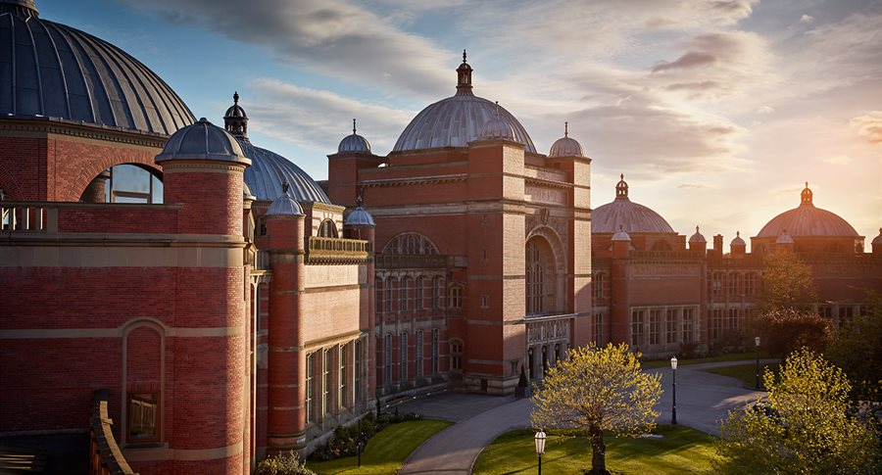
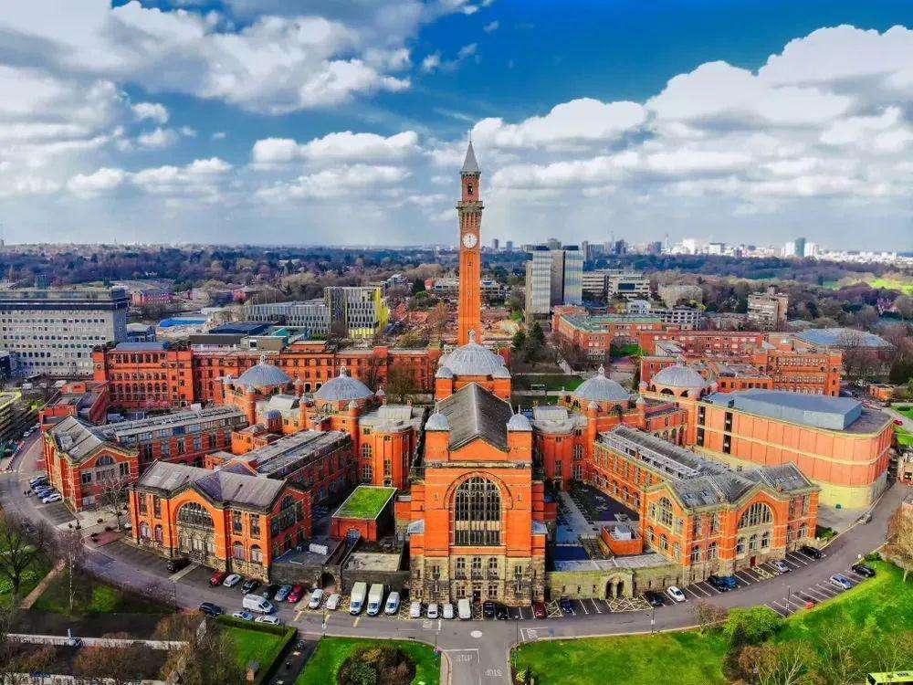

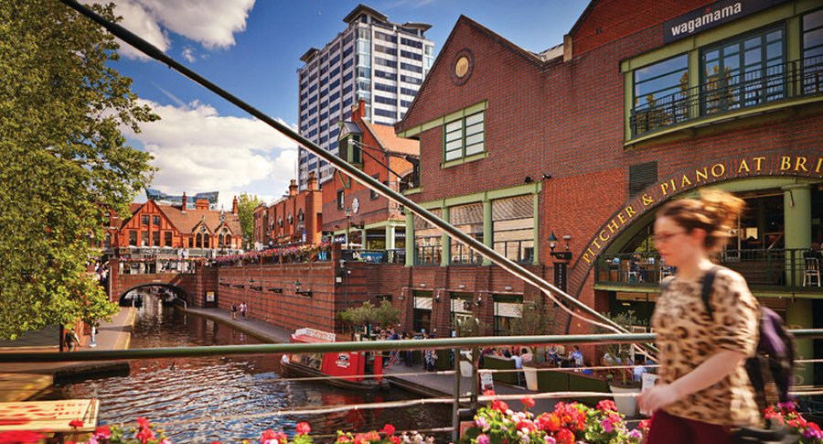

- Richmond, The American International University in London里士满美国国际大学 (https://www.richmond.ac.uk/)
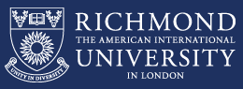
Introduction
Richmond is an American International University, established in 1972 and based in West London with two campuses in Richmond Hill and close to Kensington High Street. Since 1981, the university has been awarding US Degrees accredited by The Middle States Commission on Higher Education. One of the latest achievement that Richmond is proud to announce, is being granted the power to award students with its own UK degrees starting from August 2018, as a consequence of having been recently granted Taught Degree Awarding Powers (TDAP) by the Privy Council.
The university is the first and the only university in the UK that has been granted the power to award dual taught degrees, which mean students will receive a UK and US degree that will impact enormously our graduates while looking for employment opportunities and make them stand out from the crowd.
Richmond was originally an American College, founded by the social entrepreneur and politician Sir Cyril Taylor, chairman of the American Institute For Foreign Study (AIFS) and has been used as the London base for the US study abroad programme.
Since its opening in 1978, the Kensington campus buildings on St Albans Grove and Ansdell Street accommodate the third and fourth year undergraduate students as well as all postgraduate students. In March 1988 Kensington campus saw a further expansion on Young Street, that was officially opened by Diana, Princess of Wales, and attracted a number of high-profile students including royals and members of most influent families.
The University is unique for its private institution academic standards, in its teaching approach that combines the American Liberal Arts system with the UK higher education standards, which empowers our graduates with a competitive edge and opens up more opportunities to find employment either in UK or in the US.
The undergraduate degrees we offer explore a wide range of subjects and programmes allowing a broad based education, whereas the postgraduate programmes include the option to take specific electives that will define a degree minor/major. The key benefits that this private university offers, among others are, more academic mentorship and teaching time (15 hours per week in average) than in any other UK University, a strong focus on promoting international opportunities through a broad range of credit-based and integrated internships, and study abroad programmes in our teaching centres in Italy (Rome and Florence).

交换生项目申请
- 选拔对象：本科二年级学生
- 学习期限：一学年（9月至次年6月）
- 派出名额：两名
- 我校收取费用：暨南大学第三学年学费
- 语言要求：雅思6.0分或托福80分
- 绩点及综合测评要求：均排在本专业前30%

Programmes for International Students
London is a vibrant city and exciting city to live and study in. Our Study Abroad students are based in our Kensington Campus, which is in the heart of the city. You are close to Kensington Palace, The V&A, The Natural History Museum and many more amazing sites.
Richmond offers a wide range of programmes in the Humanities, Social Sciences, Business and the Arts. A full list of our programmes can be found here: https://www.richmond.ac.uk/undergraduate-programmes/. So whether or not it is classes in International Business, an Internship with a London-based fashion PR agency, or a summer drawing class in historic Italy, there are plenty of opportunities for you to experience.
Study Abroad students are encouraged to participate in the life of the University, from trips, clubs & societies to International Night.

