荷兰
- 鹿特丹大学Erasmus University Rotterdam (https://www.eur.nl/)

Introduction
Erasmus University Rotterdam has been in existence in its present form since 1973. Its history, however, dates back to 1913, the year in which the Netherlands School of Commerce (NHH) was founded through private initiative with broad support from the Rotterdam business community. In 1973, the Medical Faculty Rotterdam and the Netherlands School of Economics merged to become Erasmus University Rotterdam – the first university in the Netherlands named for a person, a man to whom Rotterdam owes the reputation it has held for centuries in the academic world, Desiderius Erasmus.
In 2009, the International Institute of Social Sciences became part of Erasmus University. ISS is an internationally renowned institute in the field of development studies and international cooperation.
Erasmus University College was established in 2013. EUC is an international undergraduate Liberal Arts & Sciences college and a prominent international research university.
Erasmus University Rotterdam is, according to the QS Ranking, the best Dutch university in the field of Accounting and Finance and Business and Management. QS by Subject EUR scores in the top 50 for the following subjects: Business & Management Studies (#17), Development Studies (#32), Medicine (#37), Social Sciences and Management (#46), Accounting and Finance (#43), Social Sciences and Management (#46), Life Sciences and Medicine (#54).

交换生项目申请
- 选拔对象：本科二年级新闻类学生
- 学习期限：一学年（9月至次年6月）
- 派出名额：三名
- 我校收取费用：暨大第三学年学费及对方学费约6000欧元
- 语言要求：雅思7.5分
- 绩点及综合测评要求：均排在本专业前30%

Programmes for Exchange Students
Erasmus University Rotterdam (EUR) consists of different faculties. These faculties together offer a wide variety of study programmes. Of course, this will bring up the question:Which faculty offers the subjects that interest you?
By selecting the 'Discipline' that speaks to you on the study programme page (https://www.eur.nl/en/education/bachelor/overview), you'll get a perfect overview of everything that's available.
About the City
Rotterdam is the host of many famed events, such as International Film Festival Rotterdam (IFFR), Rotterdam Marathon, North Sea Jazz Festival and Wereldhavendagen.
Rotterdam is home to many different types of museums and art galleries. As Lonely Platet states: "From cutting edge contemporary galleries to one of the oldest museums in the Netherlands, Rotterdam has a diverse collection of art and it’s not just confined to museums – you´ll find outdoor sculptures, installations and street art spread throughout the city." Does this quote need any addition? Don’t think so! Get outside and visit Rotterdam’s culture!
Not only in town, but also on campus there are different events taking place every week organised by different departments, faculties and associations. Want to be updated? And did you know that Erasmus University Rotterdam kicks off the academic year with it's own festival.
Rotterdam offers an extensive amount of sharing mobility services to sustainably travel around the city. With initiatives such as MoBike, Donkey Republic, Uber JUMP, and Felyx, there are plenty of affordable options to travel from A to B. Sharing mobility services are ideal means to discover the city on a sunny day as an alternative to public transport in a sustainable manner.

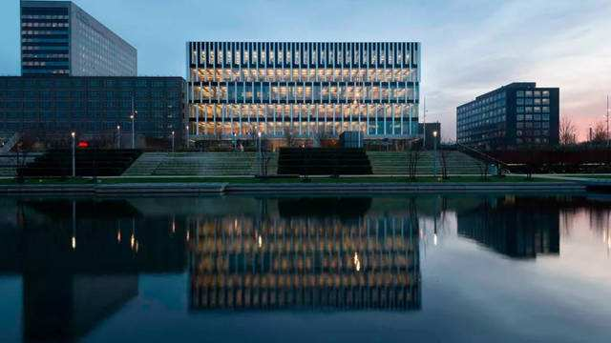
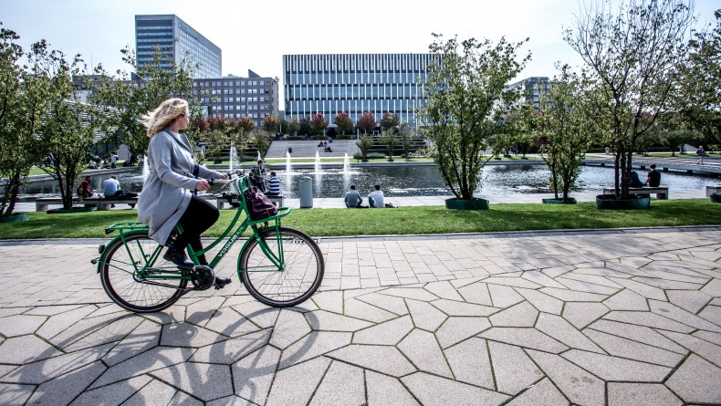
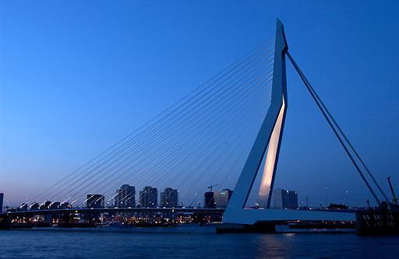
- 埃文斯应用科技大学Avans University of Applied Sciences

学校简介
埃文斯应用科技大学（Avans University of Applied Sciences）由三个校区组成，主校区坐落于荷兰南部著名城市布雷达，毗邻比利时。
学校下设有六个学院：国际商务学院、科技学院、信息技术与管理学院、健康、就业与社会行为管理学院、人文艺术与设计学院、师资培训学院。学校为本科生和研究生提供34个专业，包括：专业设置有国际金融管理、 应用生物科学与分子研究、 环境工程与管理等。
该校和欧洲及北美的许多学校有校际交流关系。近年来，为迎合教育规模化、专业化的发展趋势，该校先后与蒂尔堡高等专业大学、邓博契学院合并，并更名为艾文思高等专业大学，成为荷兰目前规模最大的高等专业大学之一。由此，专业领域将进一步扩大。目前，该校有三个学院是“TULIP荷兰郁金香高等教育联合体”的成员：勃拉帮特国际商务学院、勃拉帮特科技学院和邓博契学院。

交换生项目申请
- 选拔对象：本科二年级经管类学生
- 学习期限：一学期（9月至次年1月）
- 派出名额：五名
- 我校收取费用：暨大第三学年学费
- 语言要求：雅思6.0分或托福80分
- 绩点及综合测评要求：均排在本专业前30%

About the City
布雷达坐落于荷兰南部的北布拉班特省，在马克河和阿河的汇合处，是一个有着悠久历史背景城市，也是一座别具特色的城市。该市于1252年建立，是大机器制造业中心，还有食品、冶金、纺织、塑料等工业。2009年布雷达市与扬州市缔结为友好城市。
布雷达舒适的居住和工作环境，受到了来自于各方的赞誉，其市中心已经发展成为整个城市的经济，娱乐和文化的中心。除了现代化的设施外，该城市还拥有众多的古老建筑和城壕，大教堂为这座城市最知名的地标建筑，历史可以追溯至1269年，为哥特式建筑风格，教堂的塔楼高达97米。布雷达沙斯剧院是一座由赫尔曼·赫兹伯格设计建造的现代用途的艺术表演剧场，上演节目的范围涵盖从舞蹈到小剧场演出，从大型保留剧目到少数族群戏剧，以及从电影首映到歌剧和流行音乐会。除此之外，游客还可参观布雷达城堡、布雷达市政厅、圣安东尼教堂等。

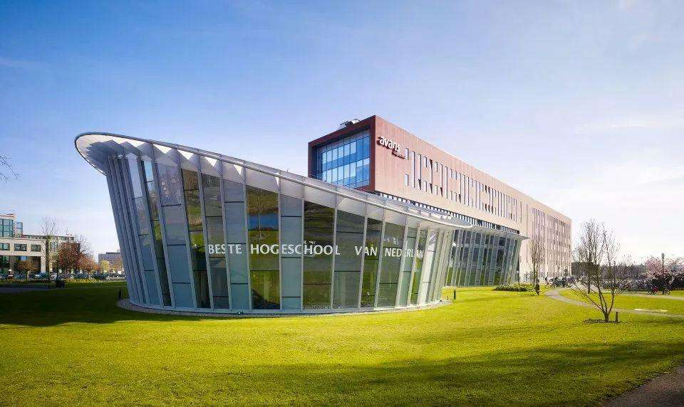

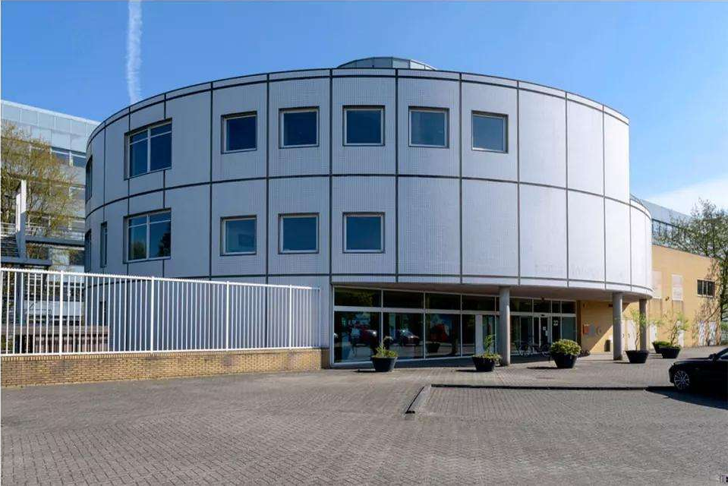

- 泽兰德大学 Hogeschool Zeeland
学校简介
荷兰泽兰德大学是荷兰国家教育部所属的一所著名公立大学，现有全日制学生四千人左右，其中有四百人是来自世界各地的海外留学生。学生所获文凭、学位获全球承认。该大学下设有经济学系、海事系、教育系、工程和技术系、卫生学系及国际研究生学院，教学设施先进，学习环境优越。
由于地域优势，泽兰德大学的水资源管理专业在荷兰排名第一，而由于旅游是当地的支柱产业，旅游管理的学生实习就业都有很好的机会。
泽兰德大学是一所中小型的大学所以更注重个性化教学，每个国际学生都配有一个学习导师可以更好的帮助国际学生适应新的环境。
泽兰德大学与全球知名公司和机构保持着很好的关系，在校生有机会在那里实践，毕业生有机会在那里找到相关的工作。两个学期的公司实习。

交换生项目申请
- 选拔对象：本科二年级经管类学生
- 学习期限：一学期（9月至次年1月）
- 派出名额：两名
- 我校收取费用：暨大第三学年学费
- 语言要求：雅思6.0分或托福80分
- 绩点及综合测评要求：均排在本专业前40%

About the City
泽兰德大学位于弗利辛恩市，它是荷兰西南部港市。在西斯海尔德河口，瓦尔赫伦岛南岸，距海牙西南约88公里。人口4.6万（1981）。重要商港和渔港，海军基地。弗利辛恩是进入斯海尔德河航行时的领航站。有炼油、造船、钢铁等工业。海滨胜地。

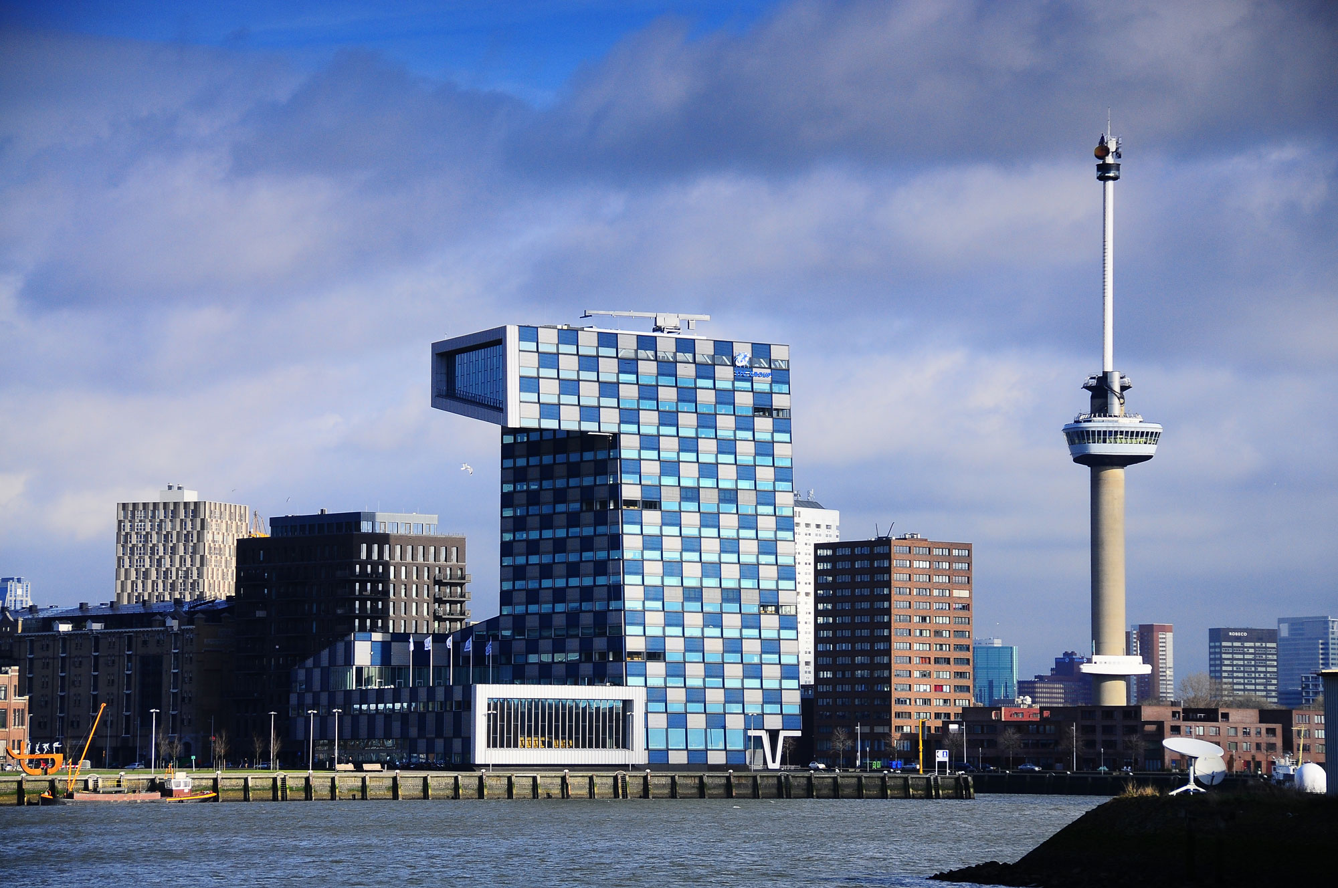

- 阿姆斯特丹应用技术大学 (https://www.amsterdamuas.com/)
Amsterdam University of Applied Sciences
Introduction
AUAS have 250 partner institutes across 50 different countries and contribute to various international educational projects such as curriculum development, research projects, student/lecturer exchanges and work placements. This ensures that the education, and research activities, provided by AUAS are internationally orientated. It is a founding member of the Urban Research and Education Knowledge Alliance (U!REKA). This unites eight European higher education institutions, which have formed a strategic alliance around the shared themes of applied research, professional education, focus on our students’ future world of work and the professional development of our staff.
The university of applied sciences consists of seven faculties. We have a total of 45,460 students and offer 92 Bachelor’s, Master’s and Associate degree programmes. We are one of the biggest employers in the field of higher education, and in Amsterdam, with some 4,066 staff members.

交换生项目申请
- 选拔对象：本科二年级经管类学生
- 学习期限：一学期（8月至次年1月）
- 派出名额：两名
- 我校收取费用：暨大第三学年学费
- 语言要求：雅思6.0分绩

Exchange Programmes
AUAS offers a variety of exchange programmes, please check the website below to find more information:
https://www.amsterdamuas.com/education/exchange/exchange-programmes/exchange-programmes.html

STUYDING AND LIVING IN AMSTERDAM
Amsterdam is one of the safest cities in the world and new students have no issue becoming familiar with the city. Amsterdam is home to people from 181 nations and English is widely spoken. Student life in Amsterdam is very exciting and there is a lot to do. This page provides useful info and will introduce you to some cool activities:
https://www.amsterdamuas.com/practical-matters/prospective-students/auas/student-affairs/student-life-amsterdam/student-life-in-amsterdam.html
